
Safeguarding and Child Protection Policy 2026

Officer Responsible for Policy | Joanne Sheen
Approval Committee | Full Governor Board
Effective Date | 1st September 2026
Next Review Date | 1st September 2027

Introduction

This document is the Safeguarding and Child Protection Policy for Harvills Hawthorn Primary School and any extended services that it provides.
This policy applies to all staff (teaching and non-teaching), governors and volunteers, temporary and supply/visiting staff working in the school. For the purposes of ease, please assume the term “staff”, used throughout this policy refers to all of these groups. It will be reviewed annually by the Governing Body and is in line with the expectations of Ofsted which inspects safeguarding arrangements as part of the school’s Leadership and Management and the requirements of the Local Safeguarding Partnership.
This Safeguarding and Child Protection Policy forms one part of the school’s safeguarding responsibilities and should be read in conjunction with the following policies:

- Safer Recruitment Policy.
- Relationships, Behaviour and Culture Policy.
- Attendance Policy.
- Physical Intervention Policy.
- Anti-Bullying Policy.
- Acceptable Use Policy.
- Anti-Extremism Policy.
- Staff Code of Conduct
- Online Safety policy
- Whistleblowing Policy
- Any other relevant policies as defined in the Annual Report to The Governing Body

As a primary setting, we are mindful of the more common safeguarding issues that can affect children up to 11 years old. We are however committed to ensuring that all our staff understand all safeguarding issues and have an awareness that anything can happen. Sadly, some safeguarding issues such as Child Criminal Exploitation and Child Sexual Exploitation do happen with children of primary age and staff must all be aware and show vigilance.

Terminology

Safeguarding and promoting the welfare of children | • providing help and support to meet the needs of children as soon as problems emerge  • protecting children from maltreatment, whether that is within or outside the home, including online  • preventing the impairment of children’s mental and physical health or development  • ensuring that children grow up in circumstances consistent with the provision of safe and effective care  • taking action to enable all children to have the best outcomes (KCSIE 2026)
Child Protection | Refers to the processes undertaken to protect children who have been identified as suffering or being at risk of suffering significant risk of harm.
Staff | Refers to all those working for or on behalf of the school, full time or part time, temporary or permanent, in either a paid or voluntary capacity.
Child | Refers to any person under the age of 18.
Parent/s | Refers to birth parents and other adults who are in a parenting role. For example, stepparents, foster carers (including kinship carers) and adoptive parents.

Purpose of a Safeguarding Policy

The purpose of this policy is to inform all members of staff, parents, volunteers, and governors about the school's responsibilities for safeguarding children and their responsibilities therein.  Good safeguarding practice helps schools promote and maintain a safer culture which protects and promotes the welfare of children, young people and vulnerable adults. These features are: | - A leadership commitment, at all levels, to the importance of safeguarding and promoting the welfare of children and young people.  - A clear line of accountability for all safeguarding work with clarity of roles and responsibilities.  - Clear reporting procedures to deal with safeguarding concerns and allegations.  - Practice and services informed by ongoing learning, review, and by the active involvement of student voice and parent participation.  - Clear arrangements for support for adults involved in safeguarding.  - Comprehensive safeguarding training for all staff and volunteers working with or in contact with children, young people and their families. | - Safer recruitment procedures in place and followed rigorously.  - Effective working with statutory and voluntary sector partners.  - Complaints and whistleblowing procedures that are well publicised.  - Effective information sharing.  - Good record keeping.  - Regular training and / or updates.  - Thorough induction of new staff.

Principles
- This school recognises its responsibility to protect and safeguard the welfare of the children and young people entrusted to its care by establishing a safe and trusting environment in which children can learn and develop.
- The policy applies to all children between the ages of 0-18 whose care and education comes within the remit of this school. (For some special education settings, this age range goes beyond 18).
- The staff and Governing Body of this school are committed to establishing and maintaining an environment where children feel secure, are encouraged to talk, and are listened to. We will ensure that children know there are adults in the school who they can approach if they are worried and that the principles of confidentiality are made clear to children and young people.
- Children need to be supported in approaching any member of staff they feel most comfortable in speaking with. The school promotes a positive, supportive, and secure ethos, giving pupils a sense of being valued.
- To ensure children know that there are adults in the school whom they can approach if they are worried.
- This school also recognises its duty to work with other agencies in protecting children from harm and in responding to concerns about possible abuse, including the Police, Child and Adolescent Mental Health Services (CAMHS), Attendance & Prosecution Service, Inclusion Support Service and other agencies/services working with pupils.
- To ensure that children who are subject to multi-agency plans are supported by the school as defined in that plan.
- To develop and deliver the PSHE curriculum to create opportunities for children to develop the skills they need to recognise and stay safe from harm including education and training in relation to Sexual Violence and Harassment, Domestic Abuse (DA), Child Criminal Exploitation (CCE), Female Genital Mutilation (FGM) So-called “Honour”-based abuse (HBA), Forced Marriage (FM), Misogyny, Racism, Homophobia, Sexism and Radicalisation.
- To provide training to ensure all staff are confident in their safeguarding duties.
- To encourage pupils to respect the fundamental British Values. We ensure that partisan political views are not promoted in the teaching of any subject in the school and where political issues are brought to the attention of the pupils, reasonably practicable steps have been taken to offer a balanced presentation of opposing views to pupils.
- To contribute to children being healthy, safe, enjoying and achieving, making a positive contribution, and achieving economic well-being.
- The school will ensure that parents have an understanding of the responsibility placed on staff for child protection by setting out its obligations in the school prospectus. The Safeguarding and Child Protection policy is made available to parents on request and published on the school website.
Implementation, Monitoring and Review of this Policy | The DSL will ensure that the Safeguarding and Child Protection policy is put on the agenda of the Governing Body at least once a year for discussion, monitoring, review, and renewal. In this way the Governing Body authorises the DSL for Child Protection to carry out his/her responsibilities as outlined in the statutory guidance.

West Midlands Child Protection Safeguarding Procedures

These child protection and safeguarding procedures are for nine Safeguarding Partnerships in the West Midlands and have been effective from 31st March 2017. http://westmidlands.procedures.org.uk/

Schools and Academies within Sandwell often have young people attending who live in any one of the Local Authorities. It is therefore important that all staff are aware of the reporting procedures for all Local Authorities. The school will continue to liaise with the Local Authority Children’s Services that they are situated in, and the DSL will keep up to date with information from the neighbouring Local Authorities.

While the following details are for reporting a concern in Sandwell, you can use this site to find details of procedures elsewhere in the West Midlands.
Worried about a child?
Is it an emergency? | If a child is at immediate risk of significant harm, please call 999 in the first instance for police and/or ambulance services and then contact Sandwell Children’s Trust on 0121 569 3100. You will then need to complete a MARF without delay.
Non-emergency but still concerned? | If you have safeguarding or child protection concerns about a child, you should use Sandwell’s Multi Agency Request Form (MARF) to report your concerns to the Multi Agency Safeguarding Hub (MASH).  For advice and guidance on when and how to complete a MARF you can consult Sandwell’s Multi Agency Threshold Guidance; Continuum of Help and Support and this 7 minute briefing- MARFFor advice and guidance on when and how to complete a MARF you can consult Sandwell’s Multi Agency Threshold Guidance; Continuum of Help and Support and this 7 minute briefing- MARF
What does MASH mean? | Children’s social care can be contacted via the MASH (Multi-Agency Safeguarding Hub) which has been formed to protect children and families who may be at risk of harm including domestic abuse. It is a co-located multi agency team which securely shares information between agencies. The information is used to understand the needs of a child or adult about whom concerns have been raised. The MASH identifies a full picture of the known risks affecting the children and their family and then ensures timely and relevant actions to address these issues.
Completing a MARF | For advice and guidance on when and how to complete a MARF you can consult Sandwell’s Multi Agency Threshold Guidance; Continuum of Help and Support and this 7 minute briefing- MARFFor advice and guidance on when and how to complete a MARF you can consult Sandwell’s Multi Agency Threshold Guidance; Continuum of Help and Support and this 7 minute briefing- MARF
I have some concerns but I’m not sure they’re serious enough | Option 1 |  | Option 2 |  |  | Option 3
I have some concerns but I’m not sure they’re serious enough | Check the Multi Agency Threshold Guidance; Continuum of Help and Support or speak to Sandwell Childrens’ Trust on 0121 569 3100 or your local Strengthening Families Team (see below)Check the Multi Agency Threshold Guidance; Continuum of Help and Support or Speak to Sandwell Childrens’ Trust on 0121 569 3100 or your local Strengthening Families Team (see below) |  | If you believe that Early Help services will be able to assist the family, this can be offered through universal services and community-based early help (including support based in school) or a referral can be made to the targeted early help level of Family Help (see option 3).  Offer the family community-based early help. This means referring or signposting to local services or putting in support within school. The family will need to consent to this. |  |  | With consent, a referral can be made to the targeted early help level of Family Help via the e-caf system (training is available at the website address www.sandwell.gov.uk/integratedworking).  Alternatively, a paper Early Help Assessment obtained from the website can be sent in which should be e-mailed securely to: ecaf_queries@sandwell.gov.uk
You may wish to liaise with one of the Strengthening Families Teams in Sandwell regarding a family who needs/already has Early Help support.
Tipton  Sandwell Local – High Street, Princes End, Tipton DY4 9JB  Tel: 0121 569 7294  Email: tipton_strengtheningfamilies@sandwell.gov.uk |  | Wednesbury  Wednesbury Town Hall, Holyhead Road, Wednesbury WS10 7DF  Tel: 0121 569 7294  Email: wednesbury_strengtheningfamilies@sandwell.gov.uk |  | West Bromwich  The Court House, High Street, West Bromwich B70 8LU  Tel: 0121 569 7293  Email: westbrom_strengtheningfamilies@sandwell.gov.uk | Other useful Contacts include:  - Sandwell MASH Team – 0121 569 3100  - Dudley MASH Team – 0300 555 0050  - Birmingham MASH Team – 0121 675 1669  - West Midlands Police – 101 or in an emergency 999  - Sandwell Local Authority Child Protection Officers for Education – 0121 569 8144  - Numbers for LADOs can be found in Section 11 of this policy.  https://www.sandwellchildrenstrust.org/contact-us/
Oldbury  Sandwell Council House – Freeth St, Oldbury B69 3DB  Tel: 0121 569 7295  Email: oldbury_strengtheningfamilies@sandwell.gov.uk |  | Rowley Regis  Sandwell Local – Payne Street, Blackheath, Rowley Regis B65 0DH  Tel: 0121 569 7296  Email: rowley_strengtheningfamilies@sandwell.gov.uk |  | Smethwick  Smethwick Council House, High Street, Smethwick B66 3NT  Tel: 0121 569 7297  Email: smethwick_strengtheningfamilies@sandwell.gov.uk

Legislation and Statutory Guidance

This policy is based on the Department for Education’s statutory guidance Keeping Children Safe in Education (2026) – hereto abbreviated to KCSiE - and Working Together to Safeguard Children (2026), - hereto abbreviated to WTtSC - and the Governance Handbook. We comply with this guidance and the arrangements agreed and published by our 3 local safeguarding partners. |  | All staff are instructed to read Part 1 of KCSiE.  Section 3 of the Early Years Foundation Stage (EYFS) statutory framework (linked below) should be read alongside KCSIE where children aged 0 to 5 attend school-based nurseries or reception classes.
The following safeguarding legislation and guidance has also been considered when drafting this policy:
- Legislation | - Statutory Guidance |  | - Non-statutory Guidance
- Children Act 1989 (legislation.gov.uk)  - Children Act 2004 (legislation.gov.uk)  - Safeguarding Vulnerable Groups Act 2006 (legislation.gov.uk)  - The Education (School Teachers’ Appraisal) (England) Regulations 2012 (legislation.gov.uk)  - Sexual Offences Act 2003 (legislation.gov.uk)  - Female Genital Mutilation Act 2003 (legislation.gov.uk)  - Serious Crime Act 2015 (legislation.gov.uk)  - Apprenticeships, Skills, Children and Learning Act 2009 (legislation.gov.uk)  - Equality Act 2010 (legislation.gov.uk)  - Counter-Terrorism and Security Act 2015 (legislation.gov.uk)  - UK General Data Protection Regulation  - Data Protection Act 2018  - The Childcare (Disqualification) and Childcare (Early Years Provision Free of Charge) (Extended Entitlement) (Amendment) Regulations 2018 (legislation.gov.uk)  - Voyeurism (Offences) Act 2019 (legislation.gov.uk)  - Domestic Abuse Act 2021 (legislation.gov.uk)  - Marriage and Civil Partnership (Minimum Age) Act 2022 (legislation.gov.uk) | - HM Government Multi-agency practice guidelines: Handling cases of Forced Marriage (publishing.service.gov.uk)  - Multi-agency statutory guidance on female genital mutilation - GOV.UK (www.gov.uk)  - Channel and Prevent Multi-Agency Panel (PMAP) guidance - GOV.UK (www.gov.uk)  - Channel Duty Guidance: Protecting people vulnerable to being drawn into terrorism (publishing.service.gov.uk)  - Prevent duty guidance - GOV.UK (www.gov.uk)  - Disqualification under the Childcare Act 2006 - GOV.UK (www.gov.uk)  - Alternative provision - GOV.UK (www.gov.uk)  - Supporting pupils with medical conditions at school - GOV.UK (www.gov.uk)  - EYFS Statutory Framework |  | - Information sharing advice for safeguarding practitioners - GOV.UK (www.gov.uk)  - Child exploitation disruption toolkit - GOV.UK (www.gov.uk)  - Sharing nudes and semi-nudes: advice for education settings working with children and young people - GOV.UK (www.gov.uk)  - ICO Employment Practice and Data Protection  - Recruit teachers from overseas - GOV.UK (www.gov.uk)  - Virginity testing and hymenoplasty: multi-agency guidance - GOV.UK (www.gov.uk)  - Working together to improve school attendance - GOV.UK (www.gov.uk)  - Meeting digital and technology standards in schools and colleges -  - Keeping children safe in out-of-school settings - GOV.UK (www.gov.uk)  - Promoting and supporting mental health and wellbeing in schools and colleges - GOV.UK (www.gov.uk)  - Mental health and behaviour in schools (publishing.service.gov.uk)  - Right to work checks: an employer's guide  - https://www.gov.uk/guidance/plan-technology-for-your-school  - Generative AI: product safety standards

The Designated Safeguarding Lead

The Designated Safeguarding Lead (DSL) for child protection will co-ordinate action on child protection within the school. The DSL is to have the overall contextual safeguarding view for all students within the school. This means to have an understanding of wider community issues when we consider the wellbeing and safety of young people. This includes ensuring that all staff, teaching, and non-teaching (including supply staff) know who the DSL is and that they are aware of their individual responsibility to be alert to the signs of abuse and to discuss any concerns with the DSL.
Important Factors: | They will be given the time, funding, training, resources and support to: | Their duties include (but are not limited to):
- The DSL for Safeguarding and Child Protection is a member of the Senior Leadership Team. The full responsibility of the DSL is set out in their job description, in line with Annex B of KCSiE 2026.  - The DSL holds lead responsibility for online safety inc. the filtering and monitoring systems and processes in place.  - At least one Deputy DSL should be appointed to act in the absence/unavailability of the DSL. To ensure continuity and enable safeguarding concerns to be received, monitored, and acted upon without delay; we will implement robust cover arrangements for longer periods when the DSL is unavailable due to illness, leave, or other circumstances.  - The DDSL is/are trained to the same level as the DSL and supports the DSL with safeguarding matters as appropriate. In the event of the long-term absence of the DSL, the deputy will assume the functions above.  - In the absence of the DSL and any deputies, the most senior member of staff in the school will assume responsibility for any child protection matters that arise.  - However, if there is no person qualified to DSL level, staff members must understand their duty to report any Child Protection concerns directly to the Local Authority using the details provided earlier in this policy. | - Provide advice and support to other staff on safeguarding, welfare and child protection matters.  - Take part in strategy discussions and inter-agency meetings and/or support other staff to do so.  - Contribute to the assessment of children. If children do not require the support of statutory children’s services, the DSL will lead the liaison with other agencies and setting up an inter-agency assessment as appropriate. Where necessary and most suitable, the DSL may act as Lead Practitioner for any such inter-agency meetings.  - Refer suspected cases, as appropriate, to the relevant body (Children’s social care, Channel programme, Disclosure and Barring Service, and/or police).  - Support staff who make such referrals directly. | - Keep the school’s SLT, Governors, Local Authority and Local Children’s Safeguarding Partnership informed about safeguarding and child protection issues as requested.  - Regularly risk assess (using the Prevent Duty risk assessment tool amongst others) and review the effectiveness of the filtering and monitoring systems and all online safety processes.  - Compile and submit a written report regarding children who are subject to Child Protection conferences. This should be shared with parents before the conference takes place.  - Ensure there is appropriate representation on Core Groups when a child is on a child protection plan. If the most appropriate person is a class teacher, there must be joint working with the DSL.  - Ensure there is appropriately trained staff to lead on and that all staff are aware of the Early Help process and the importance of implementing Early Help at any stage in a child’s life, in order to improve outcomes.  - Ensure that welfare records are kept securely and confidentially using an electronic software for recording.  - Managing the safeguarding training process for staff, ensuring that all school staff and Governors receive regular and appropriate safeguarding training.  - Track trends and provide strategic leadership over all areas of safeguarding with a focus on prevention of harm.

Key personnel
The Designated Safeguarding Lead (DSL) for child protection is: | Joanne Sheen | Contact Details: 0121 5571034
The Deputy Designated Safeguarding Lead(s) (DDSL) is/are: | Maxine Soper  Michelle Hellend  Ryan Brydon  Hayley Marsden  Kit Salmon  Carla Maxwell  Sam Hill  Josh Hill | Contact Details: 0121 5571034
The nominated child protection governor is: | Nicola Cooke | Contact Details: 0121 5571034
The Chair of Governors is: | Nicola Cooke | Contact Details: 0121 5571034
The Headteacher is: | Joanne Sheen | Contact Details: 0121 5571034

The Governing Body

The Governing Body has overall responsibility for ensuring that there are sufficient measures in place to safeguard the children in their establishment. The nominated governor for child protection takes lead responsibility and will work more closely with the DSL. Please see Appendix D for further detail. The Governing body will:

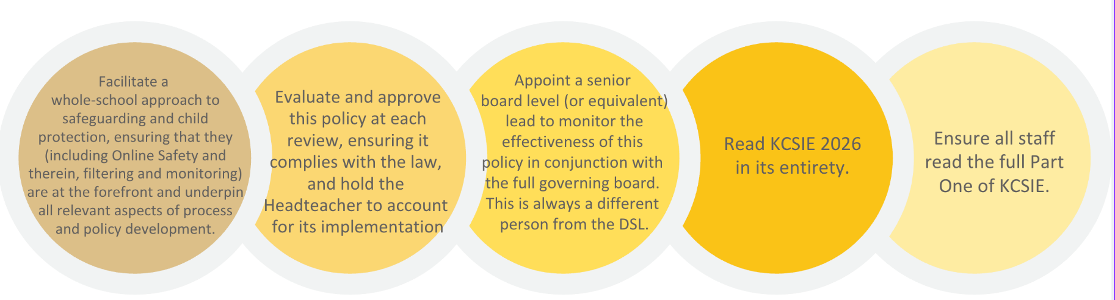

The Headteacher is responsible for the implementation of this policy, including:
- Ensuring that all staff (including temporary staff) and volunteers:
- Are informed of systems which support safeguarding, including this policy, as part of their induction.

- Understand and follow the procedure included in this policy, particularly those concerning referrals of cases of suspected abuse, neglect and exploitation.
- Communicating this policy to parents/carers when their child joins the school and via the school website.
- Ensuring the DSL has appropriate time, funding, training, and resources, and that there is always adequate cover if the DSL is absent.
- Ensuring that all staff undertake appropriate safeguarding and child protection training and updating the content of the training regularly.
- Acting as the ‘case manager’ in the event of an allegation of abuse made against another member of staff or volunteer, where appropriate.
- Ensuring the relevant staffing ratios are met, where applicable.
Please see the appendices for further information.

School Procedures – Staff Responsibilities

All staff need to be alert to the potential abuse of children both within their families and from other sources, including members of the school community.
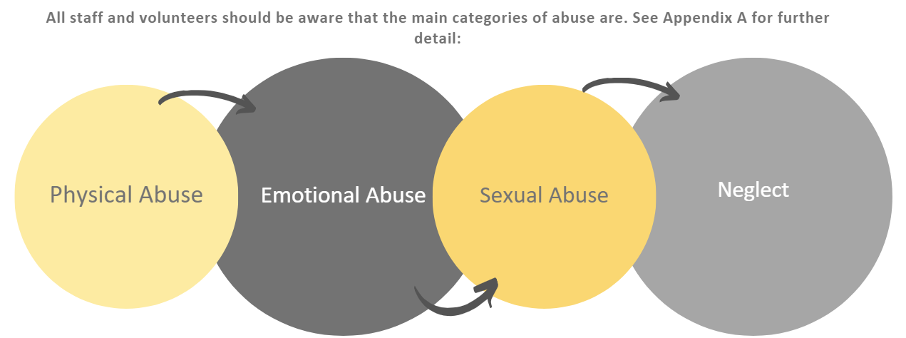
All staff should maintain an attitude of “it could happen here” and should use their professional curiosity to spot signs and indicators that a child could be at risk of harm.
If any member of staff is concerned about a child, the DSL (or a DDSL in their absence) must be informed immediately. There is an absolute responsibility for all members of the school to respond to any suspected or actual abuse of a child in accordance with these procedures.

Good Practice:
The Staff Behaviour Policy (or Staff Code of Conduct) clearly outlines how a staff member should behave and present themselves. Please read this document for further detail. Good practice for staff when it comes to safeguarding includes (but is not limited to):
- Treating all pupils with respect and encouraging positive, respectful, and safe behaviour among pupils.  - Reporting any matters both within, and where it is appropriate, outside of the workplace (including online), which may have implications for the safeguarding of children.  - Referring all concerns about a pupil’s safety and welfare to the DSL, or, if necessary, directly to police or Children’s Social Care.  - Setting a good example by conducting ourselves appropriately, both online and offline.  - Understanding that children may not disclose abuse, neglect and exploitation and therefore, use professional curiosity to be alert to changes in pupils’ behaviour and to signs of abuse, neglect, and exploitation. | - Recognising that challenging behaviour may be an indicator of abuse.  - Involving pupils in decisions that affect them.  - Asking the pupil’s permission before initiating physical contact, such as assisting with dressing, physical support during PE or administering first aid.  - Maintaining appropriate standards of conversation and interaction with and between pupils and to avoid the use of humiliating, sexualised or derogatory language.  - Applying the use of reasonable force only as a last resort and in compliance with school and Local Safeguarding Children’s Partnership procedures.
Abuse of Position of Trust
All school staff are aware that inappropriate behaviour towards pupils is unacceptable and that their conduct towards pupils must be beyond reproach.

In addition, staff should understand that, under the Sexual Offences Act 2003, it is an offence for a person over the age of 18 to have a sexual relationship with a person under the age of 18, where that person is in a position of trust, even if the relationship is consensual. This means that any sexual activity between a member of the school staff and a pupil under 18 may be a criminal offence, even if that pupil is over the age of consent.

Please see the appendices for further information.

Children Potentially at Further Risk of Harm

Some children may have an increased risk of abuse. It is important to understand that this increase in risk is due more to societal attitudes and assumptions or child protection procedures that fail to acknowledge children’s diverse circumstances, rather than the individual child’s personality, impairment, or circumstances. Many factors can contribute to an increase in risk, including prejudice and discrimination, isolation, social exclusion, communication issues and a reluctance on the part of some adults to accept that abuse can occur.
All staff should be particularly alert to - and report to the DSL - the potential need for additional support and/or Early Help for a child who: | - is disabled or has certain health conditions and has specific additional needs  - has special educational needs (whether or not they have a statutory Education, Health and Care plan)  - is a young carer  - is pregnant and/or is a parent themselves  - has exhibited early signs of abusive, violent and/or harmful sexual behaviours  - is showing signs of being drawn in to anti-social or criminal behaviour, including gang involvement and association with organised crime groups or county lines  - is frequently missing/goes missing from education, home or care  - is at risk of exploitation, modern slavery, trafficking, including criminal or sexual exploitation | - has been repeatedly removed from the classroom, experienced multiple suspensions, is on a part-time timetable, is at risk of being permanently excluded from schools, colleges and in Alternative Provision or a Pupil Referral Unit  - is at risk of being radicalised into terrorism  - has a parent or carer in custody, or is affected by parental offending  - is in a family circumstance presenting challenges for the child, such as drug and alcohol misuse, adult mental health issues and domestic abuse  - is misusing alcohol and other drugs themselves  - is at risk of faith-based abuse or so-called “honour”-based abuse such as Female Genital Mutilation or Forced Marriage  - is a privately fostered child  - has a mental health need

Children Missing in Education (CMIE) and Children who are absent from Education | Put simply, school attendance and safeguarding are inextricably linked.  A child going missing from education is a potential indicator of abuse, neglect and exploitation.  The DSL will closely monitor attendance, unauthorised absence and exclusions and take appropriate action including notifying the local authority, particularly where children go missing on repeated occasions and/or are missing for periods during the school day.  Staff must use their professional curiosity and be alert to signs of children at risk of travelling to conflict zones, human trafficking, female genital mutilation and forced marriage.  The school works to the Working Together to Improve School Attendance statutory guidance. | Actions we take to safeguard these children include (but are not limited to):
- Following up with parents when young people are not at the school. This means we need to have at least two up to date contact numbers for parents.

- Training staff to monitor changes in attendance and/or punctuality (Inc. spotting the signs and triggers for travelling to conflict zones, FGM and forced marriage) and respond swiftly

- Implementing policies and responses for pupils who go missing from education (especially on repeat occasions) or are persistently absent or absent for prolonged periods

- Work to procedures to inform the local authority (LA) when we plan to take pupils off-roll when they:
- Leave the school to be home educated (if a child who is electively home educated has an EHCP we make the LA aware so they can review the plan working with parents/carers to ensure the child’s needs are met)
- Move away from the school’s location
- Remain medically unfit beyond compulsory school age
- Are in custody for four months or more (and will not return afterwards)
- Are permanently excluded

- Ensuring that CYP who are expected to attend the school but fail to take up the place, are referred to the local authority.

- When a CYP leaves the school, we record the name of their new school or setting and expected start date.

Mental Health
- Mental health problems can, in some cases, develop into safeguarding concerns. This could include self-harm, signs of an eating disorder, suicidal ideation or suicide. Furthermore, mental health problems can, in some cases, be an indicator that a child has suffered or is at risk of suffering abuse, neglect or exploitation.  - School staff are not expected or trained to diagnose mental health conditions or issues. However, if a child is struggling with their mental health, self-harming, has an eating disorder or is experiencing suicidal ideation and making plans to end their life, there are likely to be potential warning signs which staff are well placed to recognise. They should always report these to the DSL. | - Staff therefore know to report to the DSL as a matter of urgency, if a child makes any reference to suicide. Staff understand that disclosures of suicidal ideation are rare and therefore they must be alert to jokes, insults and comments that may hide true feelings. Staff will also ensure any comments online about suicide or notes, drawings and doodles that raise concern must also be reported.  - If you have a mental health concern about a child, this should be reported to the DSL in order that support can be offered at an early stage.

Young Carers
All staff are alert to the needs of young carers, recognising that caring responsibilities can impact on their attendance, attainment, behaviour and wellbeing.  We prioritise early identification to ensure young carers receive support at the right time. This includes (but is not limited to): | - Asking for information about caring responsibilities in initial registration information for the pupil  - Sharing information with families to encourage open communication about a child’s caring responsibilities  - Training all staff to spot the signs that a child may be a young carer and ensuring these are reported to the DSL  - Including information about Young Carers in assembly and PSHE to ensure that children are aware of the concept, and where relevant, can recognise themselves and seek support.

Pupils with a Social Worker, and Children in Care or Previously in Care
Pupils may need a social worker due to safeguarding or welfare needs. We recognise that a child’s experiences of adversity and trauma can leave them vulnerable to further harm as well as potentially creating barriers to attendance, learning, behaviour and mental health.
The DSL and all members of staff will work with and support social workers to help protect vulnerable children.
Where we are aware that a pupil has a social worker, the DSL will always consider this fact to ensure any decisions are made in the best interests of the pupil’s safety, welfare and educational outcomes.
For example, it will inform decisions about: |  | - Responding to unauthorised absence or missing education where there are known safeguarding risks.  - The provision of pastoral and/or academic support
Staff are trained in the skills, knowledge and understanding to keep Children in Care (CIC also referred to as LAC, meaning Looked After Children) and Children Previously in Care (PCIC also referred to as PLAC meaning Previously Looked After Children) as well as those in kinship care arrangements safe.
In particular, we will ensure that: | - Appropriate staff have relevant information about children looked after legal status, contact arrangements with birth parents or those with parental responsibility, and care arrangements. |  | - The DSL has details of children’s social workers and relevant virtual school heads in order to work together to maximise the child/ren’s educational attendance, attainment, and progress.
We have appointed a designated teacher (DT), Joanne Sheen, (Maxine Soper and Ryan Brydon are also trained) who is responsible for promoting the educational achievement of CIC and PCIC in line with statutory guidance. The DT is appropriately trained and has the relevant qualifications and experience to perform the role.
As part of their role, the DT will: | - Work closely with the DSL to ensure that any safeguarding concerns regarding looked-after and previously looked-after children are quickly and effectively responded to  - Work with Virtual School Headteachers to promote the educational achievement of looked-after and previously looked-after children (including those in kinship care). This will include discussing how pupil premium plus funding can be best used to support children in care and meet the needs identified in their personal education plans

Pupils with Special Educational Needs (SEN) or Disabilities or Health Needs
- We recognise that pupils with SEND may be more vulnerable to a range of safeguarding risks including exploitation, physical abuse, sexual abuse and bullying, amongst others. |  | - It is important to read the SEND Code of Practice for further information around this: SEND code of practice: 0 to 25 years - GOV.UK (www.gov.uk) | We work with a range of organisations including SENDIASS to ensure that the needs of pupils with SEND are fully catered for.
All staff are trained to understand not only the barriers to reporting, but also, the barriers for staff to spot signs and indicators of abuse, neglect and exploitation in children with SEND.  These include the following: | 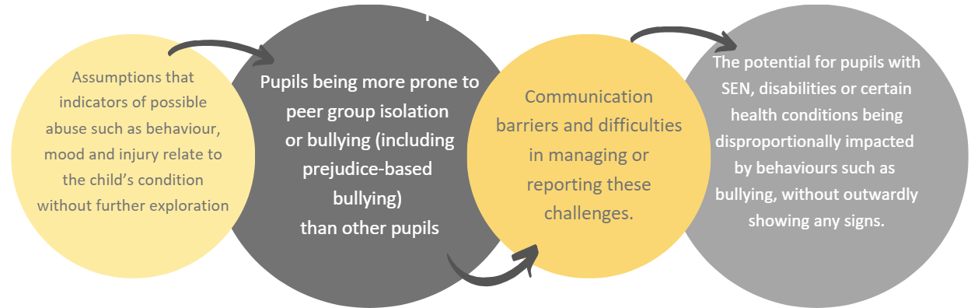

LGBT+ Children (or those perceived to be by others
When we use the term LGBT+, we are referring to Lesbian, Gay, Bisexual, Transgender children and young people. The ‘+’ encompasses a range of identities including (but not limited to) Queer, Questioning, Intersex, Asexual and Pansexual. For the purposes of this policy, we are referring to all students who identify as LGBT+ and including those thought or assumed to be LGBT+ by others (both adults, other children and young people).
Whilst all our staff are trained to understand that identifying as LGBT+ is not a safeguarding concern in and of itself; they are also trained to understand that LGBT+ children and young people can be at increased risk of various forms of abuse, neglect and exploitation.
Examples include an increased risk of | Experiencing online bullying |  |  | Forced marriage if their family or community are not accepting of their sexuality/ identity |  | Sexual violence and harassment | Suicide and self-harm, particularly amongst Transgender young people.
Risks can be compounded where children who are LGBT+ lack a trusted adult with whom they can be open. Therefore: |  |  | In line with guidance outlined in KCSiE 2026, all staff are trained to provide a safe space for all LGBT+ pupils (including those assumed to be or treated as so by others). This is to enable them to speak out or share their concerns with whichever member of staff with whom they feel comfortable to do so. Risks can be compounded where children who are LGBT+ lack a trusted adult with whom they can be open.
The school takes a Zero Tolerance approach to any forms of child-on-child abuse including all forms of violence and harassment such as: |  | - Sexism  - Homophobia  - Misogyny and Misandry  - Racism  - Sexual Violence and Harassment |  |  | This approach is promoted consistently within school and taught to all pupils through a planned programme of age-appropriate PSHE and Relationships Education. This details issues including: |  |  | - Consent  - Boundaries  - Body confidence  - Stereotyping  - Harassment
Please note that when referring to homophobia, we also hold a zero-tolerance approach towards any form of Biphobia, Transphobia or any form of bullying or harassment towards someone based upon their sexuality or gender identity. This includes children and young people who are gender-questioning or identify as ‘non-binary’. This is designed to uphold each student’s Human Rights and Protected Characteristics. Please see appendix J for more information on supporting gender-questioning children.

Children are taught to keep themselves safe.

Children are taught to understand and manage risk through our Personal, Social, Health education (PSHE), Relationships and Health education (RHE) and throughout their broad and balanced curriculum. We use a myriad of ways to teach about safeguarding including within assemblies, drop down, using visiting speakers and within lessons. These lessons are differentiated for children who may require further support – such as those with SEND or children who have experienced abuse.
Our approach is designed to help children to think about risks they may encounter and with the support of staff work out how those risks might be reduced or managed. Discussions about risk are empowering and enabling for all children and promote sensible behaviour rather than fear or anxiety. Children are taught how to conduct themselves and how to behave in a responsible manner, including understanding our Zero Tolerance approach to all forms of harassment and discrimination (as mentioned above). Children are also reminded regularly about online safety, the risks of sharing content and images online and tackling bullying and cyber-bullying.

Complaints, Allegations and Whistleblowing

Complaints | Whistleblowing and Allegations against Staff
- Our complaints procedure will be followed where a pupil/ parent raises concerns about poor practice towards a pupil that initially does not reach the threshold for child protection action.  - Poor practice examples include unfairly singling out a pupil or attempting to humiliate them, bullying, or belittling a pupil or discriminating against them in some way.  - Complaints are managed by senior staff, the Headteacher and Governors.  - Complaints from staff are dealt with under the school’s Complaints and Disciplinary and Grievance procedures.  - Complaints which escalate into child protection concerns will be managed under this policy. | - Staff who are concerned about the conduct of a colleague towards a pupil are undoubtedly placed in a very difficult situation. They may worry that they have misunderstood the situation and might wonder whether a report could jeopardise their colleague’s career. All staff must remember that the welfare of the child is paramount.  - Ongoing vigilance is taken by the Governing body to maintain an environment that deters and prevents abuse and challenges inappropriate behaviour. As part of this, the school has taken steps to create the right culture and environment so that staff feel comfortable to discuss matters both within, and where it is appropriate, outside of the workplace (including online), which may have implications for the safeguarding of children.  - The school’s whistleblowing policy enables staff to raise concerns or allegations, initially in confidence and for a sensitive enquiry to take place. Please see the policy for further detail – which can be accessed via the school website.  - If you have concerns about a member of staff (including a supply teacher, volunteer, or contractor), or an allegation is made about a member of staff posing a risk of harm to children, speak to the Headteacher as soon as possible. If the concerns/allegations are about the Headteacher, speak to the chair of governors. The Headteacher/chair of governors will then follow the procedures set out in appendix H, if appropriate.  - Staff may also report their concerns directly to children’s social care, the LADO (local authority designated officer) or the police if they believe direct reporting is necessary to secure action.  - Staff, parents, and governors are reminded that publication of material that may lead to the identification of a teacher who is the subject of an allegation is prohibited by law. Publication includes verbal conversations or writing, including content placed on social media sites.  - Allegations concerning staff who no longer work at the school, or historical allegations will be reported to the police.  - The full procedures for dealing with allegations against staff can be found in KCSiE 2026 and in the school’s Managing Allegations policy and procedures.
 | Helpful information includes: | https://www.gov.uk/whistleblowing  https://www.nspcc.org.uk/what-you-can-do/report-abuse/dedicated-helplines/whistleblowing-advice-line/
In summary, however – the following situations would constitute an allegation against a member of staff:
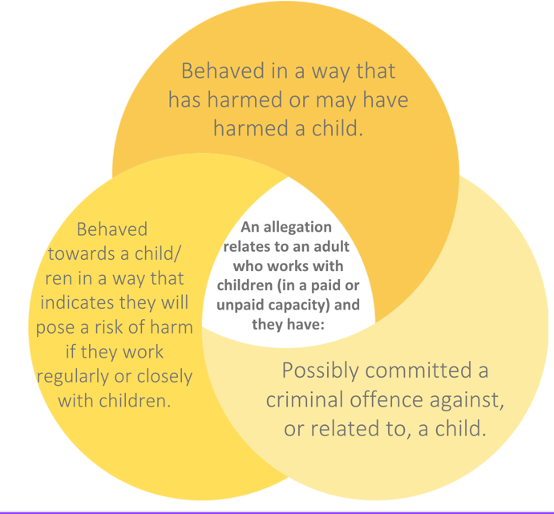 |  |  | - The Headteacher (or Chair of Governors in the case of allegations against the Head) will not investigate the allegation itself, or take written or detailed statements, but will consult with the Local Authority Child Protection Officers, when appropriate, and if necessary, make a referral will be made to the LADO.  - Further details including what should be done about low-level concerns (concerns that do not meet the threshold above) can be found in the appendices. If a concern is brought to the headteacher’s or Chair of Governors’ attention and the threshold for the LADO Service is met, they will complete a written referral. This should be sent within 24 hours of the incident to:  access_team@sandwellchildrenstrust.org

You can also contact the LADO to discuss any concerns about a volunteer/employee without making a formal referral. This is an informal discussion. | Dudley LADO  Yvonne Nelson-Brown – 01384 813110  Sukhchandan Kaur – 01384 813066  General LADO Line: 01384 813061  allegations@dudley.gov.uk | Wolverhampton LADO  Contact the team on 01902 550661 or 01902 550477  LADO@secure.wolverhampton.gov.uk
Sandwell LADO  Charlotte Mullings  0121 569 4770  sandwell_lado@sandwellchildrenstrust.org | Walsall LADO  Belinda Crowshaw  01922 652322  lado@walsall.gov.uk | Birmingham LADO  0121 675 1669.  ladoteam@birminghamchildrenstrust.co.uk

Staff Training

- All staff members will undertake safeguarding and child protection training at induction, including on whistle-blowing procedures and online safety (including filtering and monitoring), to ensure they understand the school’s safeguarding systems and their responsibilities, and can identify signs of possible abuse or neglect. Staff must understand their responsibilities in connection with education and understanding of sexual violence and sexual harassment.
- All staff will have safeguarding training upon induction and further training throughout the year may include online training or face-to-face training. Staff will also receive regular safeguarding and child protection updates, including on online safety, as required but at least annually (for example, through emails, e-bulletins, and staff meetings).
- All training will be in line with advice from the 3 safeguarding partners and up to date legislation and guidance on safeguarding.
- All staff will have training on the government’s anti-radicalisation strategy, Prevent, to enable them to identify children at risk of being drawn into terrorism and to challenge extremist ideas.
- All staff will be made aware of the increased risk to abuse of certain groups, including disabled and SEN children, LGBTQ+ children, looked after children (including those in kinship care) and young carers.

Safer Recruitment

Our school endeavours to ensure that we do our utmost to recruit and employ safe staff (including visitors and contractors) by following the guidance in KCSiE 2026 together with the LCSP and the school’s Staff Recruitment policy and procedures.
For anyone working with children or vulnerable adults, the law requires the fulfilment of numerous duties to keep them safe. Fundamentally, people who are barred from certain activities involving children and vulnerable adults must not work for any school. Working with children or adults at risk, is classed as 'regulated activity'. In an educational setting, 'regulated activity' is defined as teaching, training, instructing or supervising children or providing advice or guidance on physical, emotional or educational wellbeing, or, driving a vehicle only for children, e.g. school transportation

For further detail, we adhere to the guidance on Safer Recruitment within KCSiE 2026. Key elements of safer recruitment practice in our school include (but are not limited to):
- Safeguarding must be considered at every stage of the recruitment process, planning, advertising, interview and appointment.  - All job descriptions must include responsibility for safeguarding children, and all person specification must include reference to suitability to work with children.  - The job advert must state that any successful candidate will be subjected to an enhanced DBS check (with barred list for any staff or volunteers working in regulated activity) and for specific management posts a s128 check, and that online checks will be carried out for all applicants invited for interview.  - Careful selection of the recruitment panel (inc. shortlisting and interview) with at least one member has had specific Safer Recruitment training |  | - Two references must be obtained from the current and previous employer.  - Candidates must bring all relevant documents to interview.  - Thorough and robust pre-employment checks must be undertaken before the successful candidate begins work.  - All documentation gathered as part of recruitment must be stored securely and confidentially.  - We may use the ‘Check a teacher’s record service’ to make GTCE, prohibition, direction, restriction, and children’s barred list checks.
Regulated Activity | Site Security | Volunteers | Contractors
Schools and academies are ‘specified places’ which means that the majority of staff and volunteers will be engaged in regulated activity. A fuller explanation of regulated activity can be found in part 3 of KCSiE 2026. | - Visitors, including contractors, are asked to sign in and given a badge, confirming they have permission to be on site. Parents who are simply delivering/ collecting their children do not need to sign in.  - All visitors are expected to observe the school’s safeguarding and health and safety regulations to ensure children in the school are kept safe. The Headteacher will exercise professional judgment in determining whether any visitor should be escorted or supervised while on site. | - Volunteers, including governors will undergo checks commensurate with their work in the school and contact with pupils. Under no circumstances will a volunteer who has not been appropriately checked, be allowed to engage in regulated activity.  - Volunteers who are not in regulated activity will undergo the safe recruitment checks appropriate to their role, in accordance with the school’s risk assessment process and statutory guidance. | The school checks the identity of all contractors working on site and requests DBS checks and barred list checks where required by statutory guidance. Contractors who have not undergone checks will not be allowed to work unsupervised or engage in regulated activity.

Extended School and Off-site arrangements

All extended school and off-site activities are subject to a risk assessment to satisfy health and safety and safeguarding requirements. Where extended-school activities are provided by and managed by the school, our own Safeguarding and Child Protection policy and procedures apply.
When our pupils attend off-site activities, including day and residential visits and work-related activities, we will check that effective child protection arrangements are in place. A DSL/DDSL will always be available to discuss concerns. However, in the unlikely case that they cannot be contacted, staff are to follow the procedures outlined elsewhere within this policy and report child protection concerns to the MASH directly.
Use of School Premises
If other organisations provide services or activities on our site, we will check that they have appropriate procedures in place, including safer recruitment procedures, and Safeguarding and Child Protection policy and procedures.

If we receive an allegation relating to an incident that happened when an individual or organisation was using the school premises for the purposes of running activities for children (for example community groups, sports associations, or service providers that run extra-curricular activities); we may follow our own safeguarding policies and procedures, including informing the LADO and referring to MASH as outlined elsewhere in this policy.

Please note – The DSL has a responsibility to ensure all incidents and allegations relating to safeguarding are responded to and addressed appropriately - whether or not they relate to children who are students at the school. This may mean gaining confirmation that the organisation’s own safeguarding lead has taken action – or alternatively, referring to MASH and/or the police.
All staff should be aware that if they have concerns about a child who has used the school premises for any activity, this must be reported to the DSL.

Photography and Images

The vast majority of people who take or view photographs or videos of children do so for entirely innocent and legitimate reasons. Sadly, some people abuse children through taking or distributing images, so we must ensure that we have safeguards in place: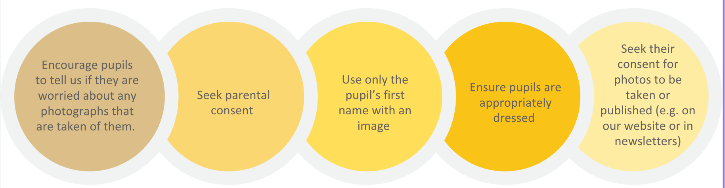
Please note, with the prevalence of deepfake CSA images, sometimes created using images shared online, increasingly some schools are moving away from using any real images, rather using stock photography or AI-generated images of children. While we have chosen not to do this currently, we have moved towards a policy of not using images of children and increasingly sharing images of pupil’s work or a classroom scene rather than images of particular children. As technology develops and new dangers emerge, we will engage in dynamic and formal risk assessing, weighing up the pros and cons of sharing images of our school life. As always, the children’s safety and wellbeing is our top priority.

Online Safety

Our pupils increasingly use electronic equipment on a daily basis to access the internet and share content and images via social networking sites such as Snapchat, Instagram and TikTok. This is likely to continue even with the mobile phone ban in schools, from September 2026. Many pupils own or have access to handheld devices and parents are encouraged to consider measures to keep their children safe when using the internet and social media at home and in the community.
The school’s Online Safety Policy explains how we try to keep pupils safe in the school and protect and educate pupils in the safe use of technology.
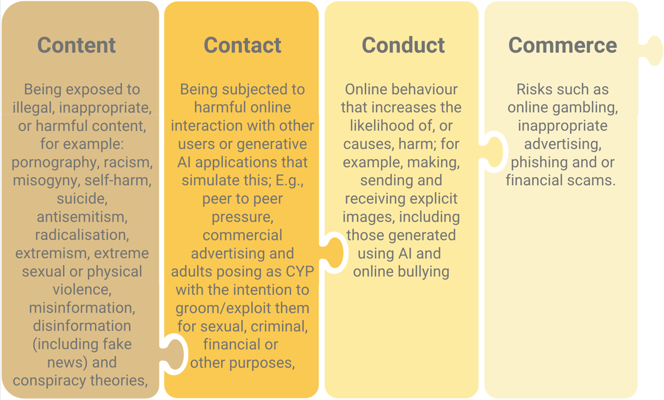
Our approach to online safety is based on addressing the following categories of risk, as outlined within KCSIE 2026:
To meet our aims and address the risks above, we will:
- Have robust processes in place to ensure the online safety of pupils, staff, volunteers and governors.
- Protect and educate the whole school community in its safe and responsible use of technology, including mobile and smart technology (which we refer to as ‘mobile phones’).
- Set clear guidelines for the use of mobile phones for the whole school community (please see section below)
- Establish clear mechanisms to identify, intervene in and escalate any incidents or concerns, where appropriate. These include any “alerts” we receive following a breach of our filtering and monitoring systems.
- Implement filtering and monitoring systems and adhere to the filtering and monitoring standards for schools and colleges ( Meeting digital and technology standards in schools and colleges - Filtering and monitoring standards for schools and colleges - Guidance - GOV.UK (www.gov.uk)
- Train staff, as part of their induction, on safe internet use and online safeguarding issues. All staff members will receive refresher training at least once each academic year.
- Educate parents/carers about online safety via our website, communications sent directly to them and during parents’ evenings. We will instruct them on how to raise concerns about online safety.
- Explain the sanctions we will use if a pupil is in breach of our policies on the acceptable use of the internet and mobile phones and devices.
- Make sure all staff, pupils and parents/carers are aware that staff have the power to search pupils’ phones, as set out in the DfE’s guidance on searching, screening and confiscation
- Carry out an (at least) annual review of our approach to online safety (including the effectiveness of our filtering and monitoring systems in safeguarding pupils) supported by an annual risk assessment that considers and reflects the risks faced by our school community. Reviews are carried out by the SLT member responsible for filtering and monitoring, with the support of the DSL and IT support.
We will make sure staff are aware of any restrictions placed on them with regards to the use of their mobile phone and cameras, for example that: | Educate pupils about online safety as part of our curriculum. For example:
- Staff are allowed to bring their personal phones to the school for their own use but will limit such use to non-contact time when pupils are not present.  - Staff will not take pictures or recordings of pupils on their personal phones or cameras.  - The school provides advice to staff regarding their personal online activity and has strict rules regarding online contact and electronic communication with pupils. This can be found within the Staff Code of Conduct. Staff found to be in breach of these rules may be subject to disciplinary action or child protection investigation.  - Make all pupils, parents/carers, staff, volunteers and governors aware that they are expected to sign an agreement regarding the acceptable use of the internet in the school and use of the school’s ICT systems | - The safe use of social media, the internet and technology  - Keeping personal information private  - How to recognise unacceptable behaviour online including recognising specific online crimes such as cyber-flashing and epilepsy trolling.  - How to report any incidents of cyber-bullying, ensuring pupils are encouraged to do so, including where they are a witness rather than a victim.  - Safety measures to protect children from accessing pornography and the reasons why.
Mobile Phones
In line with the legal changes made in 2026, all schools should be mobile phone-free environments by default; anything other than this should be by exception only.
Our policy outlines the fact that pupils should not have access to their mobile phone (or similar device such as a smart watch) throughout the school day including during lessons, the time between lessons, breaktimes and lunchtime. The policy also outlines any circumstances which would be considered “exceptional”, as well as how any breaches of the policy will be managed.

Visiting Speakers Policy

Although it has always been helpful for an school to have clear guidance on the management of visiting speakers, the Prevent Duty set out that this is now an expectation: | “As part of managing the risk of radicalisation, schools’ safeguarding policies should set out clear protocols for ensuring that any visiting speakers, whether invited by staff or by children themselves, are suitable and appropriately supervised. In England, the Prevent duty complements schools’ other responsibilities for ensuring that speakers do not undermine the fundamental British values of democracy, the rule of law, individual liberty, and mutual respect and tolerance of those with different faiths and beliefs. (Prevent Duty Guidance in England and Wales HM Government 2023 Prevent duty guidance: England and Wales (2023) - GOV.UK (www.gov.uk)
Key aspects of our policy include:
- A formal procedure for inviting speakers, which involves approval by the Headteacher, and a clear understanding of why the speaker has been chosen.  - A list of appropriate checks on the suitability of the person, which may include internet searches and/or contacting other settings where the person has spoken previously.  - Although not always possible, it is useful to invite speakers from an established company, charity or other group whose aims are well-documented.  - A document for the speaker to read and sign, to ensure that they understand they must abide by the school’s equality commitments; that there must be no statements which might cause offence to others or otherwise undermine tolerance of other faiths or beliefs; and there must be no extremist material.  - An understanding that the speaker will be expected to talk with staff about the content of the presentation before the event; speakers and staff must allow time for this discussion, whether it is on the day or beforehand. |  | - An understanding that such talks and presentations will not be used to raise funds, without the prior written permission of the Headteacher.  - Visiting speakers must arrive at reception in good time to book in and must bring suitable identification. Although viewing DBS certificates may be appropriate, most visiting speakers will not be in ‘regulated activity’ and so will not necessarily have a DBS certificate to present.  - Visitors must be supervised at all times and not left alone with pupils, unless they have confirmed DBS checks.  - Visiting speakers should understand that their presentation will be brought to an early end, if the content proves unsuitable.  - All information about the visiting speaker and the booking process should be recorded on a suitable proforma.  - After the presentation, an evaluation form should be completed which will include feedback from staff, note any contentious subject areas or comments, and state whether the speaker could be booked again in the future. Once a person has visited a school, future checks should be proportionate.

Reporting systems for students

Where there is a safeguarding concern, we will take the child’s wishes and feelings into account when determining what action to take and what services to provide. We recognise the importance of ensuring pupils feel safe and comfortable to come forward and report any concerns and/or allegations.
To achieve this, we will: | Reporting systems for our pupils:
- Put systems in place for pupils to confidently report abuse.  - Ensure our reporting systems are well promoted, easily understood and easily accessible for pupils.  - Make it clear to pupils that their concerns will be taken seriously, and that they can safely express their views and give feedback. | The following systems are regularly promoted to our pupils:  - Identifying their trusted adults in school  - Use of ‘Baskets’ in class  - Wishes and Feelings for vulnerable pupils  - make pupils aware of the reporting systems and processes, e.g., through discussion in your relationship/sex education curriculum  - reassurances provided following disclosures  - Letting the children know who the DSL is  - Childline posters  - Annual participation in NSPCC Speak out, Stay safe programme  Parents and Carers are able to – and encouraged to – report any safeguarding concerns about their child or concerns about another child. They can do this by sharing concerns with their child’s class teacher, contacting the DSL directly or by appointment, email or telephone call.

Dealing with Disclosure

Staff are aware that statistically, most children who have been affected by abuse, neglect and exploitation will never tell anyone. If they do disclose, this is most likely to be to their peers, or to a professional when they are an adult.
Staff must be aware that a lack of disclosures does not mean that children they are working with are not affecting by abuse, neglect or exploitation. Children may not disclose for a number of reasons including shame, fear of not being believed, or not feeling ready to do so. They may also feel more comfortable disclosing information on a piecemeal basis – staff must remain patient and let the child know they are safe to share information. All staff must be aware that ‘it could happen here’.
Support for those involved in a Child Protection issue.
Child abuse is devastating for the child and can result in distress for staff who become involved. We will support pupils, their families, and staff by: | - Taking all suspicions and disclosures seriously.  - Nominating a link person who will keep all parties informed and be the central point of contact.  - Where a member of staff is the subject of an allegation made by a pupil, separate link people will be nominated to avoid any conflict of interest.  - Responding sympathetically to any request from pupils or staff for time out to deal with distress or anxiety. | - Maintaining confidentiality and sharing information on a need-to-know basis only with relevant individuals and agencies.  - Storing records securely.  - Offering details of helplines, counselling, or other avenues of external support.  - Following the procedures laid down in our Safeguarding and Child protection, Whistleblowing, Complaints and Disciplinary procedures.
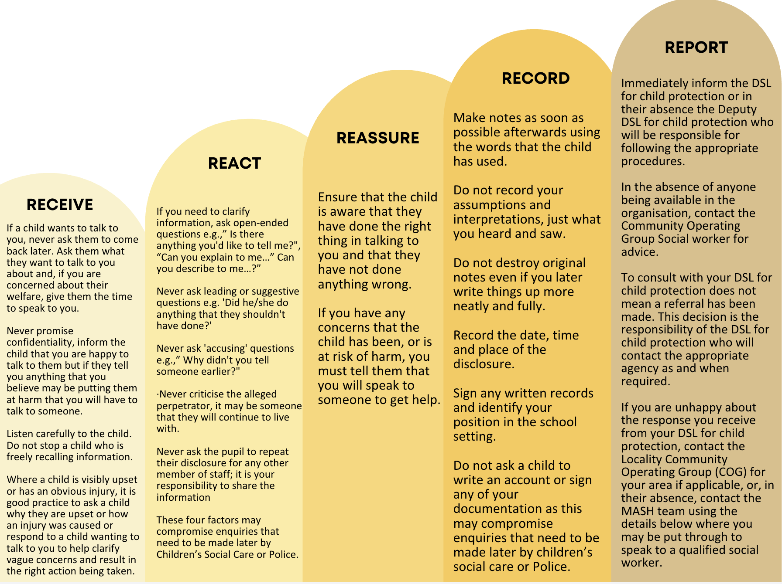
UNDER NO CIRCUMSTANCES SHOULD YOU LEAVE THE SCHOOL WITHOUT DISCUSSING YOUR CONCERNS WITH SOMEONE WHO CAN HELP
In the absence of the DSL | Making a referral
In our school, we have a DSL and several DDSLs (please view the list earlier in this policy). Therefore, there should always be someone available for you to discuss your concerns with.  If, the DSL or a DDSL cannot be found, Staff should consider speaking to a member of the senior leadership team. If not possible, this must not lead to a delay in taking action to safeguard a child (see the next box).  In these circumstances, any action taken or liaison with Children’s Social Care should be shared with the DSL (or a deputy) as soon as is practically possible. | - Please follow the advice provided within Section 3 of this policy, where you can also find links to the MARF form.  - Parents/carers should be informed if a referral is being made except in the circumstances outlined in section 19 of this policy.  - However, inability to inform parents for any reason should not prevent a referral being made to Children’s Social Care via the MASH Service. They will then decide on next steps.

Confidentiality

Safeguarding Children raises issues of confidentiality that must be clearly understood by all staff / volunteers in the school. All staff in the school, both teaching and non-teaching staff, have a responsibility to share relevant information about the protection of children with other professionals, particularly Children’s Social Care and the Police.
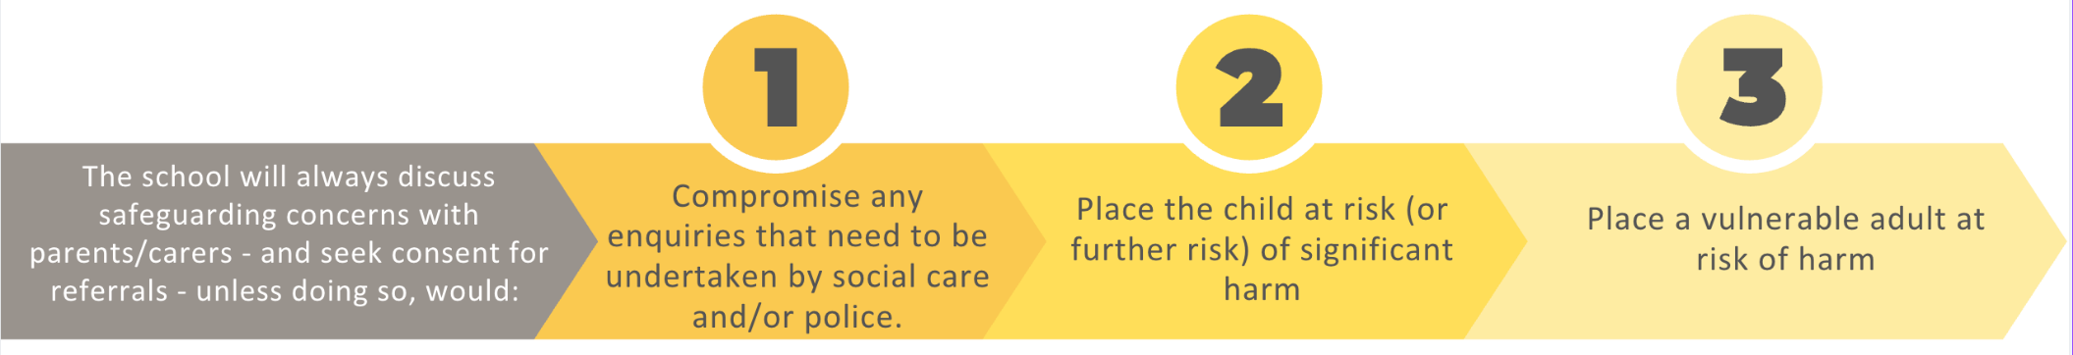
If a child wishes to confide in a member of staff / volunteer and requests that the information is kept secret, the member of staff / volunteer will tell the child, in an appropriate manner to the individual needs of the child, that they cannot promise confidentiality and may need to pass the information on to help keep the child or other children safe.

Record-Keeping

The importance of good clear child welfare and child protection record keeping has been highlighted repeatedly in Children’s Safeguarding Practice Reviews. Good up to date record keeping of concerns and action taken is essential for two main reasons: |  | 1. | It helps the school identify causes for concern at an early stage. Often it is only when a number of seemingly minor issues are seen as a whole that a pattern can be seen indicating safeguarding or child protection concern.
 |  | 2. | It helps the school monitor and manage their safeguarding practices and provides evidence of robust and effective safeguarding policy and practice.
Good practice includes: | - A record of a concern, suspicion or allegation should be made at the time of or as soon as possible after the event. Dates and times of events should be recorded as accurately as possible, together with a note of when the record was made.  - Any member of staff receiving a disclosure of abuse from a child or young person or noticing signs or symptoms of possible abuse in a child or young person, will make a written record within the hour recording the disclosure using the child’s own words, what was said or seen and the location both of the abuse and the disclosure.  - A record should be made of any visible marks or injuries to a child that give cause for concern, this may be completed on a body map. The child should not be examined intimately, or pictures taken of any injuries/marks.
At our school, we use an electronic record-keeping system, called CPOMS. |  | However, if a paper record is made, all records must be signed and dated clearly with the name of the signatory clearly printed.  For paper records, please see below for best practice:
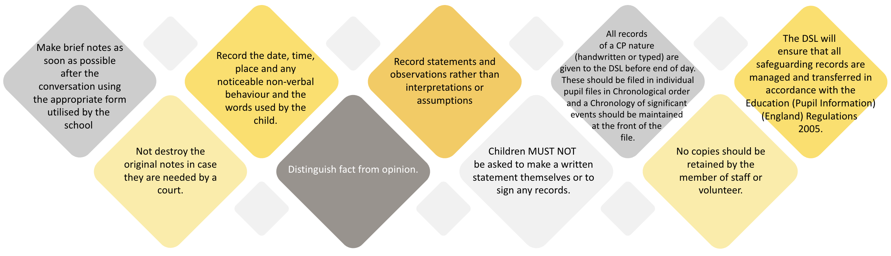

Physical Interventions

Principles |  | Guidance
It is important to allow children to do what they can for themselves, but depending on age and circumstances (i.e., a child who is hurt, who needs instruction in the use of a particular instrument/piece of equipment, safety issues such as the need to prevent a child hurting themselves or others), it may be necessary for some physical contact to take place. |  | In April 2026, the DfE published the following guidance: Restrictive interventions, including use of reasonable force, in schools - Guidance for schools in England. This can be found on the www.gov.uk website.  This guidance informs our approach, a summary of which can be read below. For further information, please read our Relationships, Behaviour and Culture Policy.
1 | Restrictive interventions should never be used as part of routine behaviour management and are used only as a last resort. Rather, prevention is the priority including use of behaviour support planning and de-escalation techniques. | 4 | Significant incidents involving restrictive interventions will be recorded and reported as soon as possible by staff members’ involved. These records will be analysed by the DSL and the Behaviour Lead in order to establish any lessons learned and how to minimise the need for such interventions in future. Governors will also have oversight of this process with the aim being to entirely reduce any need for such interventions.
2 | Any intervention must be lawful, necessary, reasonable and proportionate to the risk (e.g. risk of imminent harm) and used for the shortest possible time. | 5 | Parents/carers will be informed and there will opportunity for a debrief with staff and child/ren involved whereby (where appropriate) restorative meetings can be held to restore relationships.
3 | The guidance distinguishes between: lawful removal from a classroom, supervised spaces used to reduce risk and seclusion that prevents a pupil from leaving. Seclusion should not be used as a punishment or behaviour management strategy and requires careful justification and safeguards. | 6 | The incident will not be reported to a parent if it is considered that doing so would be likely to result in significant harm to the pupil. If that is the case, or if there is no parent of the pupil to whom the incident could be reported, then the incident must be reported to the local authority where the pupil normally lives.
Children with SEND may experience restrictive interventions differently and therefore the SENDCo will work with staff to ensure personalised behaviour support plans and reasonable adjustments (under the Equality Act) are implemented pro-actively to reduce any need for restrictive interventions.

Statutory School Policies

A full list of statutory policies can be found at: https://www.gov.uk/government/publications/statutory-policies-for-schools . Note that none of these policies relate to safeguarding and child protection. Other recommended policies to read include those listed at the beginning of this policy

Appendix A – Definitions of Abuse, Neglect and Exploitation.

Please note – some forms of abuse are also outlined within Appendix F which outlines procedures for forms of Child-on-child abuse.
Physical Abuse
Physical abuse may involve hitting, shaking, throwing, poisoning, burning or scalding, drowning, suffocating, or otherwise causing physical harm to a child. Physical harm may also be caused when a parent or carer fabricates the symptoms of, or deliberately induces, illness in a child.
Signs of possible physical abuse | Possible effects of Physical Abuse
- Any injuries not consistent with the explanation given for them.  - Injuries which occur to the body in places which are not normally exposed to falls or rough games.  - Injuries which have not received medical attention.  - Reluctance to change for, or participate in, games or swimming.  - Bruises, bites, burns and fractures, for example, which do not have an accidental explanation.  - The child gives inconsistent accounts for the cause of injuries.  - Frozen watchfulness. | Physical abuse can lead directly to neurological damage, physical injuries, disability and in extreme cases death. Physical abuse has been linked to aggressive behaviour in children, emotional and behavioural problems and learning difficulties.

Emotional Abuse
- Emotional abuse is the persistent emotional maltreatment of a child such as to cause severe and persistent adverse effects on the child’s emotional development.
- It may involve conveying to children that they are worthless (e.g., criticism, belittling, name-calling) or unloved, inadequate, or valued only insofar as they meet the needs of another person.
- It may include not giving the child opportunities to express their views, deliberately silencing them or ‘making fun’ of what they say or how they communicate.
- It may feature age or developmentally inappropriate expectations being imposed on children. These may include interactions that are beyond the child’s developmental capability, as well as overprotection and limitation of exploration and learning, or preventing the child participating in normal social interaction.
- It may involve serious bullying (including cyberbullying),
- Causing children frequently to feel frightened or in danger, or the exploitation or corruption of children.
- Some level of emotional abuse is involved in all types of maltreatment of a child, though it may occur alone.
- It is a form of emotional abuse for a child to witness or experience the abuse of others (including, for example, in cases of domestic abuse wherein a child should be considered a victim in their own right).
Signs of possible Emotional Abuse | Possible Effects of Emotional Abuse
- Depression, aggression, extreme anxiety, changes or regression in mood or behaviour, particularly where a child withdraws or becomes clingy.  - Obsessions or phobias.  - Sudden underachievement or lack of concentration.  - Seeking adult attention and not mixing well with other children.  - Sleep or speech disorders.  - Negative statements about self.  - Highly aggressive or cruel to others.  - Extreme shyness or passivity.  - Running away, stealing and lying. | If a child suffers sustained emotional abuse, there is increasing evidence of adverse long-term effects on their development. Emotional abuse has a significant impact on a developing child's mental health, behaviour and self-esteem. It can be especially damaging in infancy and can be as important as the other more visible forms of abuse, in terms of its impact on the child.

Child Sexual Exploitation (CSE)
The statutory definition of Child Sexual Exploitation (CSE) can be found in the guidance document Child sexual exploitation: Definition and a guide for practitioners (DfE 2017):

Child sexual exploitation is a form of child sexual abuse. It occurs where an individual or group takes advantage of an imbalance of power to coerce, manipulate or deceive a child or young person under the age of 18 into sexual activity (a) in exchange for something the victim needs or wants, and/or (b) for the financial advantage or increased status of the perpetrator or facilitator.
The victim may have been sexually exploited even if the sexual activity appears consensual. Child sexual exploitation does not always involve physical contact; it can also occur through the use of technology.
Signs of possible CSE: |  | Increased Vulnerability
- Acquisition of money, clothes, mobile phones, etc. without plausible explanation.  - Gang-association and/or isolation from peers/social networks.  - Exclusion or unexplained absences from school, college or work.  - Leaving home/care without explanation and persistently going missing or returning late.  - Excessive receipt of texts/phone calls.  - Returning home under the influence of drugs/alcohol.  - Inappropriate sexualised behaviour for age/sexually transmitted infections.  - Evidence of/suspicions of physical or sexual assault.  - Relationships with controlling or significantly older individuals or groups.  - Multiple callers (unknown adults or peers).  - Frequenting areas known for sex work.  - Concerning use of internet or other social media.  - Increasing secretiveness around behaviours; and  - Self-harm or significant changes in emotional wellbeing. |  | If a child suffers sustained emotional abuse, there is increasing evidence of adverse long-term effects on their development. Although the following vulnerabilities increase the risk of child sexual exploitation, it must be remembered that not all children with these indicators will be exploited. Child sexual exploitation can occur without any of these issues.  - Having a prior experience of neglect, physical and/or sexual abuse.  - Lack of a safe/stable home environment, now or in the past (domestic abuse or parental substance misuse, mental health issues or criminality, for example).  - Recent bereavement or loss.  - Social isolation or social difficulties.  - Absence of a safe environment to explore sexuality.  - Economic vulnerability.  - Homelessness or insecure accommodation status.  - Connections with other children and young people who are being sexually exploited.  - Family members or other connections involved in adult sex work.  - Having a physical or learning disability.  - Being in care (particularly those in residential care and those with interrupted care histories); and  - Concerns around sexual identity.
Learning from the Casey Audit 2025
The 2025 National Audit on Group-Based Child Sexual Exploitation and Abuse, led by Baroness Louise Casey can be read here: https://assets.publishing.service.gov.uk/media/685559d05225e4ed0bf3ce54/National_Audit_on_Group-based_Child_Sexual_Exploitation_and_Abuse.pdf

In response to some of the key findings of the audit, staff will:
Understand that a teenager's apparent willingness or relationship with an adult should not be treated as meaning they have consented to exploitation. | Avoid treating adolescents as more adult or responsible for their own abuse. This is especially pertinent considering the widespread concerns that BIPOC (and particularly black) young people are often “adultified” by both the police and within education settings. |  | Prioritise early information sharing between statutory safeguarding partners (e.g. children’s services, police etc) when necessary to protect a child.

Child Criminal Exploitation (CCE)
CCE is where an individual or group takes advantage of an imbalance of power to coerce, control, manipulate or deceive a child into any criminal activity (a) in exchange for something the victim needs or wants, and/or (b) for the financial or other advantage of the perpetrator or facilitator and/or (c) through violence or the threat of violence.
The victim may have been criminally exploited even if the activity appears consensual. CCE does not always involve physical contact; it can also occur through the use of technology.
Signs of possible CCE |  | County Lines
- children who appear with unexplained gifts or new possessions.  - children who associate with other young people involved in exploitation.  - children who suffer from changes in emotional well-being.  - children who misuse drugs and alcohol.  - children who go missing for periods of time or regularly come home late; and  - children who regularly miss school or education or do not take part in education |  | - County Lines Exploitation is just one form of Child Criminal Exploitation (CCE) although it can tend to be reported in the media interchangeably with CCE as a whole.  - County lines is a term used to describe gangs and organised criminal networks involved in exporting illegal drugs (primarily crack cocaine and heroin) into one or more importing areas [within the UK], using dedicated mobile phone lines or other form of “deal line”.’  - Exploitation is an integral part of the county lines offending model with children and vulnerable adults exploited to move [and store] drugs and money. Offenders will often use coercion, intimidation, violence (including sexual violence) and weapons to ensure compliance of victims.  - Children can easily become trapped by this type of exploitation as county lines gangs create drug debts and can threaten serious violence and kidnap towards victims (and their families) if they attempt to leave the county lines network.
Tools to help | A CSE Screening Tool MUST be completed for ALL children aged 10-18 who are subject to an Early Help Assessment or a MARF. For further information see guidance sheets regarding CSE support from CSE team within MASH.  Use the online CSE Tool from Brook  https://www.brook.org.uk/our-work/cse-e-learning-tool

Sexual Abuse
- Sexual abuse involves forcing or enticing a child or young person to take part in sexual activities, not necessarily involving a high level of violence, whether or not the child is aware of what is happening.
- The activities may involve physical contact, including assault by penetration (for example, rape or oral sex) or non-penetrative acts such as masturbation, kissing, rubbing and touching outside of clothing.
- They may also include non-contact activities, such as involving children in looking at, or in the production of, sexual images, watching sexual activities, encouraging children to behave in sexually inappropriate ways, grooming a child in preparation for abuse (including via the internet).
- Sexual abuse is not solely perpetrated by adult males. Women can also commit acts of sexual abuse, as can other children.
Signs of possible Sexual Abuse |  | Possible effects of Sexual Abuse
- Any allegations made by a child concerning sexual abuse.  - The child has an excessive preoccupation with sexual matters and inappropriate knowledge of adult sexual behaviour for their age or regularly engages in sexual play inappropriate for their age.  - Sexual activity through words, play or drawing.  - Repeated urinary infections or unexplained stomach pains.  - The child is sexually provocative or seductive with adults.  - Inappropriate bed-sharing arrangements at home.  - Severe sleep disturbances with fears, phobias, vivid dreams or nightmares which sometimes have overt or veiled sexual connotations.  - Eating disorders such as anorexia or bulimia. |  | - Disturbed behaviour including self-harm,  - inappropriate sexual behaviour,  - Sadness, depression and loss of self-esteem have all been linked to sexual abuse.  - Its adverse effects may last long into adult life. The severity of the impact on the child is believed to increase the longer the abuse continues, the more serious the abuse, the younger the child at the start, and the closeness of the relationship to the abuser.  The child’s ability to cope with the experience of sexual abuse, once recognised, can be strengthened by the support of a non-abusive adult carer who believes the child, helps the child understand the abuse, and is able to offer help and protection. Some adults who sexually abuse children were themselves sexually abused as children.
Mandatory Duty to report CSA | The duty requires staff to make a report if they: |  | Our school’s process
In April 2026 the Crime and Policing bill received Royal Assent to become the Crime and Policing Act 2026.  It introduces a new statutory duty for individuals working in regulated activity (e.g. teachers, social workers, healthcare professionals and those working in voluntary roles with children) to report sexual abuse when they are made aware of it. It therefore means not doing so would be in breach of the law. It also includes a new criminal offence of attempting to prevent someone reporting child sexual abuse (CSA). | - are told about CSA, either by a child or an adult involved |  | - At our school, all staff are trained to understand what constitutes child sexual abuse (including non-contact sexual abuse and/or online abuse).  - Staff would then need to report to Children’s Services and the police directly. However, our expectation would be that they would be supported to do so by the DSL.  - Staff should therefore make the DSL aware immediately if they need to report. However, they should not seek the DSL’s permission to make the report, nor should they delay in reporting in order to speak to the DSL first.
 | - witness CSA in person
 | - see or hear it in the form of images, videos or audio recordings

Neglect
Neglect is the persistent failure to meet a child’s basic physical and/or psychological needs, likely to result in the serious impairment of the child’s health or development.
Neglect can seriously impair a child’s health, physical and intellectual growth and development, and can cause long term difficulties with social functioning, relationships and educational progress. Extreme cases of neglect can cause death.
Neglect may occur during pregnancy as a result of maternal substance abuse. Once a child is born, neglect may involve a parent or carer failing to: | - provide adequate food, clothing and shelter (including exclusion from home or abandonment).  - protect a child from physical and emotional harm or danger.  - ensure adequate supervision (including the use of inadequate caregivers); or  - ensure access to appropriate medical care or treatment.  - It may also include neglect of, or unresponsiveness to, a child’s basic emotional needs.
Signs of possible Neglect
- Dirty skin, body smells, unwashed, uncombed hair and untreated lice  - Clothing that is dirty, too big or small, or inappropriate for weather conditions  - Untreated illnesses, infected cuts or physical complaints which the carer does not respond to |  | - Frequently left unsupervised or alone  - Frequent diarrhoea  - Frequent tiredness  - Frequently hungry or overeating junk food

Other specific forms of Abuse, Neglect and Exploitation:
Human Trafficking and Modern Slavery
It is vital that professionals understand that despite slavery having been abolished in the UK in 1834, modern slavery has continued and in fact, escalated with the Global Slavery Index estimating that in 2021, there were 49.6M people in modern slavery – a number that has since risen.
In fact, in 2024, there were 5,999 potential child victims of modern slavery referred to the UK's National Referral Mechanism (NRM), representing 31% of all potential victims. Of these children, 78% were male.

Modern slavery encompasses exploitation, including sexual exploitation, criminal financial exploitation, human trafficking and slavery, servitude and forced or compulsory labour. Exploitation can take many forms, including forced labour, slavery, servitude, forced criminality and the removal of organs.
Under the Modern Slavery Act 2015, Human Trafficking is defined as the following:

A person commits an offence if the person arranges or facilitates the travel of another person (“V”) with a view to V being exploited.
(2) It is irrelevant whether V consents to the travel (whether V is an adult or a child).
(3) A person may in particular arrange or facilitate V’s travel by recruiting V, transporting or transferring V, harbouring or receiving V, or transferring or exchanging control over V.
Examples of trafficking and modern slavery which may affect CYP: | Signs and Indicators: | What to do:
- A child being trafficked into the UK from overseas for the purposes of domestic servitude  - A child being trafficked from one side of the city to the other side of the city for the purposes of sexual exploitation (whether or not the child believes the situation is exploitative)  - County Lines exploitation – where a child is trafficked from an urban area to a rural area for the purposes of criminal exploitation (e.g. selling drugs or storing weapons). | - Sudden changes in behaviour or wellbeing — becoming unusually withdrawn, anxious, fearful, aggressive, tired, or distressed, particularly around certain people or situations.  - Frequent or unexplained absences from school — persistent lateness, missing lessons, unexplained periods away from home or school, or being seen “working” during school time, evenings or weekends (for example, in hand car washes, takeaway restaurants or nail salons)  - Signs of control by another person — appearing fearful of an adult or peer, being accompanied or monitored by someone who speaks for them, or seeming unable to make ordinary choices independently.  - Unexplained money, gifts, possessions or debts — having expensive items or money they cannot explain, owing money to someone, or talking about having to work or provide something in return for accommodation, food, protection or other needs.  - Changes in relationships, appearance or circumstances — having significantly older friends/partners, suddenly changing their appearance or social group, using unfamiliar phones/accounts, or displaying knowledge or behaviour that seems inappropriate for their age. | If a member of staff becomes concerned that a child may be at risk of MDS and/or HT, it is vital that these concerns (including disclosures or signs and indicators such as those outlined above) are reported to the DSL.  If the DSL investigates and assesses that the child is at risk and needs further support, they will refer to services such as the police, Children’s Services and the National Referral Mechanism (NRM)which is the system used within the UK to support potential victims of exploitation and modern slavery.

Safeguarding Gypsy, Roma and Traveller Children
Safeguarding children from GRT (Gypsy, Roma and Traveller) communities is vital. Although this group of children is barely mentioned in safeguarding legislation; statistically they are potentially some of the UK’s most at risk children. For example, these are children more likely to experience racism and discrimination, absence from school, health inequalities and housing instability.

For more information, please read:
- https://www.gov.uk/government/uploads/system/uploads/attachment_data/file/181669/DFE-RR043.pdf
- https://www.gypsy-traveller.org/wp-content/uploads/2017/03/A-guide-for-professionals-working-with-Gypsies-and-Travellers-in-the-public-care-system.pdf

- Fabricated or Induced Illness (formerly known as Munchausen’s Syndrome by Proxy)
- Fabricated or induced illness (FII) is a rare form of child abuse. It happens when a parent or carer exaggerates or deliberately causes symptoms of illness in the child. The parent or carer tries to convince doctors that the child is ill, or that their condition is worse than it really is. The parent or carer does not necessarily intend to deceive doctors, but their behaviour is likely to harm the child. For example, the child may have unnecessary treatment or tests, be made to believe they're ill, or have their education disrupted.
FII used to be known as "Munchausen's syndrome by proxy" - not to be confused with Munchausen's syndrome, where a person pretends to be ill or causes illness or injury to themselves. However, it should be considered by staff to be a risk of emotional harm to the child where a parent/carer fabricates their own illness/injury.
Signs of fabricated or induced illness | What to do if you suspect a child is at risk
Fabricated or induced illness (FII) covers a wide range of symptoms and behaviours involving parents or carers seeking healthcare for a child. This ranges from exaggerating or inventing symptoms, to deliberately making the child ill.  Behaviours in FII can include a parent or carer who:  - Persuades healthcare professionals that their child is ill when they're healthy.  - Exaggerates or lies about their child's symptoms.  - Manipulates test results to suggest the child is ill, for example, by putting glucose in urine samples to suggest the child has diabetes.  - Deliberately induces symptoms of illness, for example, by poisoning their child with unnecessary medicine or other substances.  NB. Cases where the parent or carer wrongly reports symptoms are much more common than cases where they induce illness in the child. | FII is a complex child safeguarding issue and needs specialist guidance and intervention.  School staff who suspect FII is happening must report their concerns to the DSL who will liaise with social services and the police and must follow local child safeguarding procedures.  If you suspect someone you know may be fabricating or inducing illness in their child, do not confront them directly. It's unlikely to make the person admit to wrongdoing and it may give them the opportunity to dispose of any evidence of abuse.  The government guidance on this is found in ‘Safeguarding Children in whom illness is Fabricated of Induced’ (15th March 2008).
Spiritual or Faith-based Abuse
Linked with emotional abuse, spiritual or faith-based abuse could be defined as an abuse of power, often done in the name of God, a Higher Power or Religion. Unfortunately, spiritual or faith-based abuse is not limited to one religion or faith community – examples of it have been found in many religious communities across the UK and around the world. This abuse of power involves manipulating or coercing someone into thinking, saying or doing things without respecting their right to choose for themselves.
Some indicators of spiritual abuse might be a leader who is intimidating and imposes their will on other people, perhaps threatening dire consequences or the wrath of God if disobeyed.
They may say that God or the individual’s Higher Power/s have revealed certain things to them and so they know what is right. Those under their leadership are fearful to challenge or disagree, believing they will lose the leader’s (or more seriously their Higher Power’s) acceptance and approval.
All suspicions of the above, must be reported to the DSL.

The UK government have released the following document which provides more information for supporting children affected by spiritual or faith-based abuse:
https://www.gov.uk/government/publications/national-action-plan-to-tackle-child-abuse-linked-to-faith-or-belief

Forced Marriage
Forced marriage is when one or both people so not consent to the marriage, but they are forced to marry one another. Force may be physical force or threats; coercion or financial abuse may take place. This is an entirely separate issue from arranged marriage. It is a human rights abuse and falls within the Crown Prosecution Service definition of domestic abuse. Young men and women can be at risk in affected ethnic groups. Whistleblowing may come from younger siblings.

Forced marriage is a CRIME. It is a form of violence against women and men, domestic abuse, a serious abuse of human rights, and where a minor is involved, child abuse.

Please note that although the victim may not feel ‘forced’ into marriage; as of February 2023, engaging in any conduct that could cause a child to marry before they turn eighteen is now a criminal offence, regardless of the absence of violence, threats, or coercion. Some refer to this as “underage marriage” however it comes under the definition of Forced Marriage.
A person’s capacity to consent can change. With the right support and knowledge, a person with a learning disability may move from a position of lacking capacity to consent to marriage, to having capacity. However, some children and adults with learning disabilities are given no choice and/or do not have the capacity to give informed consent to marriage and all it entails.
The Forced Marriage Unit (FMU) | Contact Details
Never attempt to intervene directly as a school or through a third party.  The FMU is a joint Foreign and Commonwealth Office and Home Office unit, set up in 2005 to lead on the Government’s forced marriage policy, outreach and casework. It operates both inside the UK, where support is provided to any individual, and overseas, where consular assistance is provided to British nationals, including dual nationals.  The FMU operates a public helpline to provide advice and support to victims of forced marriage as well as to professionals dealing with cases. The assistance provided ranges from simple safety advice, through to aiding a victim to prevent their unwanted spouse moving to the UK (‘reluctant sponsor’ cases), and, in extreme circumstances, to the rescue of victims held against their will. | Telephone: +44 (0) 20 7008 0151  Email: fmu@fco.gov.uk  Email for outreach work: fmuoutreach@fco.gov.uk  Facebook: Forced Marriage page  Twitter: @FMUnit
Signs and indicators include: | Increased Vulnerability
- A child getting engaged, wearing what appears to be an engagement ring or possessing other engagement gifts or jewellery.  - Discontinuation of education: A child abruptly stops attending the school or shows a sudden disinterest in education, which may indicate that they are preparing for marriage.  - Isolation: A child withdrawing from social activities, friends, and family or becoming more isolated from their usual social circles  - Early pregnancy: If a child is pregnant or has given birth at a young age, it may be an indicator of child marriage.  - Reluctance to discuss marriage: A child may become evasive or uncomfortable discussing their marital status. | Remember that all children can be at risk of forced marriage or underage marriage. Some children such as those who are LGBTQ+ or have SEND can be more vulnerable.  It is vital however to avoid viewing this as an issue that only affects children from particular ethnic, religious and cultural backgrounds.

Female Genital Mutilation (FGM)
FGM comprises all procedures involving partial or total removal of the external female genitalia or other injury to the female genital organs. It is illegal in the UK and a form of child abuse with long-lasting harmful consequences, including in many cases, death. FGM is internationally recognised as a violation of human rights of girls and women. It is illegal in most countries including the UK.
When should a referral be considered? |  |  |  |  |  | Worried about FGM?
Section 5B of the Female Genital Mutilation Act 2003 places a statutory duty upon teachers in England and Wales, to report to the police where they discover (either through disclosure by the victim or visual evidence) that FGM appears to have been carried out on a girl under 18. Those failing to report such cases may face disciplinary sanctions.  It will be rare for teachers to see visual evidence (however those providing intimate care and support may do so) and they should not be examining pupils or students, but the same definition of what is meant by “to discover that an act of FGM appears to have been carried out” is used for all professionals to whom this mandatory reporting duty applies.  Teachers must personally report to the police cases where they discover that an act of FGM appears to have been carried out.  Unless the teacher has good reason not to, they should still consider and discuss any such case with the school or college’s DSL (or a deputy) and involve local authority children’s social care as appropriate. The duty does not apply in relation to at risk or suspected cases. These should be reported to the DSL who will follow their usual procedures. |  |  |  |  |  | Call the FGM helpline if you're worried a child is at risk of, or has had, FGM.  It's free, anonymous and we're here 24/7.  0800 028 3550 or email fgmhelp@nspcc.org.uk
Useful Information: |  | https://www.gov.uk/government/uploads/system/uploads/attachment_data/file/469448/FGM-Mandatory-Reporting-procedural-info-FINAL.pdf  https://www.gov.uk/government/uploads/system/uploads/attachment_data/file/380125/MultiAgencyPracticeGuidelinesNov14.pdf  https://www.gov.uk/government/uploads/system/uploads/attachment_data/file/416323/Fact_sheet_-_FGM_-_
Signs that a child has already been subjected to, or is at risk of FGM include (but are not limited to):
- Confiding in professionals without being explicit, due to embarrassment/fear  - Spending longer than usual on the toilet due to difficulties urinating.  - Mentioning having had (or getting ready for a) “special ceremony” or going abroad to be “cut” or “prepared for marriage”  - Being from one of the ‘at risk’ communities for FGM (e.g. Kenya, Somalia, Sudan, Sierra Leon, Egypt, Nigeria, Eritrea, Yemen, Afghanistan, Kurdistan, Indonesia and Pakistan) |  |  |  | - Difficulty walking, sitting, standing. Appearing to be in pain in the abdominal or genital areas.  - Family taking a long trip abroad.  - Reluctance to undergo routine medical examinations  - Knowledge that the child’s sibling or parent has undergone FGM.  - Absences from school (or out of lesson) due to bladder, menstrual or stomach problems  - Prolonged or regular absences from school – alongside a change in behaviour (e.g. seeming withdrawn) upon return
‘One Chance’ | As with Forced Marriage there is the ‘One Chance’ rule. It is essential that settings take action without delay.  So-called ‘honour-based’ abuse (HBA) encompasses crimes which have been committed to protect or defend the honour of the family and/or the community, this includes Female Genital Mutilation (FGM), forced marriage, and practices such as breast ironing. All forms of so called HBA are abuse (regardless of the motivation) and should be handled and escalated as such.  Where staff are concerned that a child might be at risk of HBA, they must contact the DSL as a matter of urgency.
Breast Ironing |  |  |  |  | Virginity-testing and hymenoplasty
- Breast ironing (also called breast flattening) is a form of domestic abuse that affects children across the globe and within the UK.  - It is the process during which young pubescent girls’ breasts are ironed, massaged, flattened and/or pounded down over a period of time (sometimes years) in order for the breasts to disappear or delay the development of the breasts entirely.  - This might be done by the use of heated stones, a metal implement or sometimes, an elastic belt, or binder, is used to stop them from growing. Breast ironing usually starts with the first signs of puberty and is most often done by female relatives.  - Breast ironing can cause serious physical issues and is not recommended or practiced by any medical professionals nor is it taught or recommended within any of the major world religions.  - If a member of staff suspects that a child is at risk of breast-ironing, they should report this immediately to the DSL. |  |  |  |  | - Under the Health and Care Act 2022, it is illegal to carry out, offer or aid and abet virginity testing or hymenoplasty in any part of the UK. It is also illegal for UK nationals and residents to carry out the practice outside of the UK.  - Virginity testing and hymenoplasty are forms of violence against women and girls and are part of the cycle of HBA and can be precursors to child or forced marriage and other forms of family and/or community coercive behaviours, including physical and emotional control.  - Victims are pressurised into undergoing these procedures, often by family members or their intended husbands’ family to fulfil the requirement that a woman remains ‘pure’ before marriage. Those who ‘fail’ to meet this requirement are likely to suffer further abuse, including emotional and physical abuse, disownment and even so-called ‘honour’ killings.
Virginity Testing |  | Also known as hymen, ‘2-finger’ or vaginal examination - this is defined as any examination (with or without contact) of the female genitalia intended to establish if vaginal intercourse has taken place, irrespective of whether consent has been given. Vaginal examination has no established scientific merit or clinical indication.
Hymenoplasty |  | A procedure which can involve a number of different techniques, but typically involving stitching or surgery, undertaken to reconstruct a hymen with the intent that the person bleeds the next time they have vaginal intercourse. Hymenoplasty is different to procedures that may be performed for clinical reasons, e.g. surgery to address discomfort or menstrual complications.
Signs and Indicators include: |  | - A pupil is known to have requested either procedure or asks for help  - Family members disclose that the pupil has already undergone the practices  - Pain and discomfort after the procedures, e.g. difficulty in walking or sitting which was not a problem previously  - Concern from family members that the pupil is in a relationship, or plans for them to be married  - A pupil discloses other concerns that could be an indication of abuse, e.g. they may state that they do not feel safe at home, that family members will not let them out the house and/or that family members are controlling
Please note |  |  | School staff will therefore:
Victims face barriers in coming forward, e.g. they may not know that the abuse was abnormal or wrong at the time, and may feel shameful, having been taught that speaking out against family and/or the community is wrong, or being scared about the repercussions of speaking out. |  |  | - Be alert to the possible presence of stress, anxiety and other psychological or behavioural signs, and mental health support should be made available where appropriate.  - Educate pupils about the harms of these practices and dispel myths, e.g. the belief that virginity determines the worth of a woman, and establish an environment where pupils feel safe enough to make a disclosure. Pupils aged 13 and older are considered to be most at risk, but it can affect those as young as 8, and anyone with female genitalia can be a victim regardless of age, gender identity, ethnicity, sexuality, religion, disability or socioeconomic status.  - Upon spotting signs and indicators or following a disclosure; staff will report to the DSL immediately. If there is believed to be immediate danger, the police will be contacted without delay.  - The school will not involve families and community members in cases involving virginity testing and hymenoplasty, including trying to mediate with family or using a community member as an interpreter, as this may increase the risk of harm to the pupil, including expediting arrangements for the procedure.

Domestic Abuse
Children can witness and be adversely affected by domestic abuse and/or violence at home where it occurs between family members. In some cases, a child may blame themselves for the abuse or may have had to leave the family home as a result.
Types of domestic abuse include intimate partner violence, stalking, abuse by family members, teenage relationship abuse and child/adolescent to parent violence and abuse. Anyone can be a victim of domestic abuse, regardless of gender, age, ethnicity, socioeconomic status, sexuality or background, and domestic abuse can take place inside or outside of the home.
Older children may also experience domestic abuse and/or violence in their own personal relationships. This is often referred to as Teenage Relationship Abuse (TRA) or Intimate Partner Violence (IPV) and can include stalking.
Exposure to domestic abuse and/or violence can have a serious, long-lasting emotional and psychological impact on children, who under the 2021 definition, should be considered victims in their own right. It is in itself, a form of emotional abuse. Children may also cause harm to other family members, often referred to as child to parent or care giver abuse. This should be viewed as a safeguarding concern for the child themselves as well as the caregiver.
Definition:
The Domestic Abuse Act 2021 (Part 1) defines domestic abuse as any of the following behaviours, either as a pattern of behaviour, or as a single incident, between two people over the age of 16, who are 'personally connected' to each other:
(a) physical or sexual abuse.
(b) violent or threatening behaviour.
(c) controlling or coercive behaviour.
(d) economic abuse (adverse effect of the victim to acquire, use or maintain money or other property; or obtain goods or services); and
(e) psychological, emotional or other abuse.
People are 'personally connected' when they are or have been married to each other or civil partners; or have agreed to marry or become civil partners. If the two people have been in an intimate relationship with each other, have shared parental responsibility for the same child, or they are relatives.

Signs and Indicators of exposure to DA include: |  | Signs and indicators of TRA include:
- Unexplained time off, irregular attendance, or being dropped off/collected in a rushed or tense manner.  - Changes in behaviour including becoming withdrawn, anxious, aggressive, or showing sudden changes in mood or performance.  - Unexplained injuries, frequent complaints of headaches or stomach aches, or tiredness from disturbed sleep.  - Difficulties with relationships including struggling to trust adults, showing clinginess to staff, or having conflict with peers.  - Overly protective or secretive about home life  - Displaying excessive concern about going home.  - Flinching or watchfulness |  | - Signs of control including their partner monitoring their phone, social media, or movements  - Isolation from friends and family  - Withdrawal from hobbies, interests or social gatherings  - Changes in appearance or behaviour including sudden loss of confidence or dressing differently.  - Frequent minor injuries, or explanations that don’t add up.  - Signs of anxiety, depression, low self-esteem, or seeming fearful of upsetting their partner.
Operation Encompass | Operation Encompass notifications are received by school. They are added to the child’s safeguarding record. The class teacher is notified and should make sure a member of the team complete wishes and feelings with the child the same day. This is then uploaded to the child’s safeguarding file for the DSL to review if any further support is necessary. Staff should also note any other concerns, e.g. presentation, mood, disclosures etc.  If police are called to an incident of domestic abuse and any children in the household have experienced the incident, the police will inform the key adult in school (usually the DSL) before the child or children arrive at school the following day. This process is called Operation Encompass. You can read more about this in Annex A of KCSIE 2026.  The DSL will then provide support according to the child’s needs (which may include a referral to Children’s Services and/or the police) and update records about their circumstances.
The National Domestic Abuse helpline can be called free of charge and in confidence, 24 hours a day on 0808 2000 247.

Appendix B – Child Protection and the use of shared sports facilities

Sport can and does have a very powerful and positive influence on young people. It can provide valuable opportunities for success, enjoyment, achievement, personal and social development and development of positive life skills. It can help develop their self-esteem, leadership and teamwork skills. It contributes to a healthy lifestyle by encouraging young people’s physical, mental and emotional well-being.
All guidance within this section should be read in conjunction with the ‘Safer in Sports Leaflet’ – DfES  Guidance includes: | - To ensure the safety and wellbeing of young people using sports facilities within a shared environment (for example, for swimming lessons or sports competitions), a member of staff must always be present whilst using the facility.  - Staff must ensure the changing room is not being used by adults at the time children are to use them. This also applies to the use of toilet facilities.  - Adults should not change or shower at the same time as the young people using the same facility.  - Young people should be supervised at all times in the changing rooms by a member of staff or volunteer of the same sex.  - If any young person is uncomfortable changing or showering in public, no pressure should be placed on them to do so. In this instance, encourage them to change or shower at home.  - If the activity is mixed gender, separate changing facilities should be made available. Please see Appendix J for expectations for children who are questioning their gender.  - Parents should be informed on an annual basis that facilities are offsite, and the site is open to the public.  - The offsite facility must have their own Child Protection Policy and have a designated welfare officer to deal with any issues.

APPENDIX C: Private Fostering

Private Fostering
A private fostering arrangement (PFA) is one that is made privately (without the involvement of a local authority) for the care of a child under the age of 16 years (under 18, if disabled) by someone other than a parent or close relative, in their own home, with the intention that it should last for 28 days or more. Important information includes:
- A close family relative is defined as a ‘grandparent, brother, sister, uncle or aunt’ and includes half-siblings and stepparents; it does not include great-aunts or uncles, great grandparents or cousins.  - Parents and private foster carers both have a legal duty to inform the relevant local authority at least six weeks before the arrangement is due to start; not to do so is a criminal offence.  - Whilst most privately fostered children are appropriately supported and looked after, they are a potentially vulnerable group who should be monitored by the local authority, particularly when the child has come from another country. In some cases, such children are affected by abuse and neglect, or be involved in trafficking, child sexual and/or criminal exploitation or modern-day slavery. | - The school has a mandatory duty to report to the local authority where they are aware or suspect that a child is subject to a PFA. Although academies have a duty to inform the local authority, there is no duty for anyone, including the private foster carer or social workers to inform the school. However, it should be clear to the school who has parental responsibility.  - Upon becoming aware of a change of living circumstances for any child, Staff should notify the DSL including if they are notified of a PFA. The DSL will speak to the family of the child involved to check that they are aware of their duty to inform the LA.  - On admission to the school, we will take steps to verify the relationship of the adults to the child who is being registered.

APPENDIX D: The role of the Headteacher and Governing Body

The role of the Headteacher in regard to safeguarding includes (but is not limited to): | The role of The Governing Body includes (but is not limited to):
- Putting in place procedures for handling cases of suspected abuse (including allegations against staff and volunteers) which are consistent with those agreed by the governing body and local safeguarding children partnership.  - Being responsible for following local procedures for allegations against persons in a position of trust and attend all relevant meetings when required.  - Liaising with the nominated Governor on child protection issues and the school policy.  - Understanding the role of and appointing a DSL for child protection to co-ordinate action within the school and liaise with other agencies, as appropriate, on suspected cases of safeguarding and child protection.  - Ensuring the DSL receives appropriate training and support.  - Ensuring that all staff know and are alert to signs of possible abuse and know what to do if they have any concerns or suspicions.  - Making parents aware of the school Safeguarding and Child Protection Policy.  - Working with appropriate local partners to create a safe environment for children at the school.  - Ensuring that when school premises are used by members of the public; care is taken to ensure that children are not placed at risk. Where activities take place during the school day, the school and its Governing Body need to ensure that effective arrangements are in place.  - Ensuring when services or activities are provided directly by school staff, the school arrangements for child protection will apply.  - Ensure when services or activities are provided separately by a third-party using school premises, the school and its governing body or proprietor seeks assurance that the body concerned has appropriate safeguarding and child protection policies and procedures in place (including inspecting these as needed).  - In the cases as described above, ensure that there are arrangements in place to liaise with the school or college on safeguarding concerns and arrangements where appropriate. This applies regardless of whether or not the children who attend any of these services or activities are children on the roll of the school.  - The governing body or proprietor will also ensure safeguarding requirements are included in any transfer of control agreement (i.e., lease or hire agreement), as a condition of use and occupation of the premises; and will communicate that failure to comply with this would lead to termination of the agreement. | - Have a signed Safeguarding and Child Protection Policy and procedures in place that are in accordance with procedures issued by the Children’s Safeguarding Partnership procedures as well as relevant legislation and ensure the policy is made available to parents on request.  - Operate safe recruitment procedures and make sure that all appropriate checks are carried out on new staff and volunteers who will work with children, including Enhanced DBS checks as defined in the guidance issued by the Independent Safeguarding Authority (ISA)  - Have procedures for dealing with allegations of abuse against members of staff and volunteers that comply with local guidance.  - Have a senior member of the school's leadership team who is designated to take lead responsibility for dealing with child protection issues, providing advice and support to other staff, liaising with the LA, and working with other agencies and ensure that they undertake training relevant to their role at least every 2 years.  - Ensure the Headteacher, and all other staff who work with children undertake appropriate training to equip them to carry out their responsibilities for child protection effectively, that is kept up to date by refresher training annually, and that temporary staff and volunteers who work with children are made aware of the school’s arrangements for child protection and their responsibilities;  - Remedy any deficiencies or weaknesses in regard to child protection arrangements that are brought to its attention without delay.  - Ensure that a member of The Governing Body is nominated to be responsible for liaising with the LA and/or partner agencies, as appropriate in the event of allegations of abuse being made against the Headteacher.  - Review its policies and procedures annually and provides information to the LA about them and about how safeguarding and child protection duties have been discharged.  - Recognise the contribution the school can make to helping children keep safe through the PSHE curriculum.  - Ensure that there are safe and effective recruitment policies and disciplinary procedures in place which adhere to current legislation.  - Appoint an individual member of The Governing Body to champion child protection issues within the school, liaise with the Headteacher/ DSL about them, and provide information and reports to the Standards and Performance Committee. It is not appropriate for that person to take the lead in dealing with allegations of abuse made against the Headteacher, that is more properly the role of the Chair of Governors or, in the absence of a chair, the vice/deputy chair.  - Make certain that when school premises are used by members of the public; care is taken to ensure that children are not placed at risk. Where activities take place during the school day, the school and its Governing Body need to ensure that effective arrangements are in place.  - Ensure when services or activities are provided directly by school staff, the school’s arrangements for child protection will apply.  - Ensure when services or activities are provided separately by a third party, The Governing Body should seek assurance that the body concerned has appropriate policies and procedures in place and that written agreements make clear the lines of accountability. Consideration should be given, when approving a letting, as to the backgrounds of the individuals making use of the premises. A risk assessment should be conducted prior to any letting taking place; the ultimate responsibility for approving lettings rests with The Governing Body of the school.  - Whether The Governing Body acts collectively or an individual member takes the child protection lead, it is imperative that all governors undertake child protection training to understand the processes that the school should follow.

APPENDIX E: Radicalisation and The Prevent Duty

Prevent (Separate Policy Available)
Definitions | The process of a person legitimising support for, or use of, terrorist violence.
Radicalisation
Extremism | The vocal or active opposition to our fundamental British values, including democracy, the rule of law, individual liberty, and mutual respect and tolerance of those with different faiths and beliefs
Terrorism | An action that endangers or causes serious violence to a person/people; causes serious damage to property; or seriously interferes or disrupts an electronic system. The use or threat must be designed to influence the government or to intimidate the public and is made for the purpose of advancing a political, religious or ideological cause.
Schools have a duty to prevent children from being drawn into terrorism: |  | - The DSL will undertake Prevent awareness training and make sure that staff have access to appropriate training to equip them to identify children susceptible to radicalisation.  - We will assess the risk of children in our school being drawn into terrorism. This assessment will be based on an understanding of the potential risk in our local area, in collaboration with our local safeguarding partners and local police force.  - We will ensure that suitable internet filtering is in place and equip our pupils to stay safe online at school and at home.  - There is no single way of identifying an individual who is susceptible to radicalisation. Radicalisation can occur quickly or over a long period. Staff will therefore be alert to changes in pupils’ behaviour.
The government website Educate Against Hate and charity NSPCC say that signs that a pupil is being radicalised can include:
- Refusal to engage with, or becoming abusive to, peers who are different from themselves  - Becoming susceptible to conspiracy theories and feelings of persecution (including extreme misogyny and ‘Incel’ ideologies)  - Changes in friendship groups and appearance  - Rejecting activities, they used to enjoy  - Converting to a new religion  - Isolating themselves from family and friends  - Talking as if from a scripted speech  - An unwillingness or inability to discuss their views |  |  |  | - A sudden disrespectful attitude towards others  - Increased levels of anger (NB. This can include desire to take revenge on others for perceived disrespect including having declined an offer of friendship or an offer of a romantic/sexual relationship)  - Increased secretiveness, especially around internet use  - Expressions of sympathy for extremist ideologies and groups, or justification of their actions  - Accessing extremist material online, including on Facebook or Twitter  - Possessing extremist literature  - Being in contact with extremist recruiters and joining, or seeking to join, extremist organisations
Children who are susceptible to radicalisation may have low self-esteem or be victims of bullying or discrimination. It is important to note that these signs can also be part of normal teenage behaviour – staff should have confidence in their instincts and seek advice if something feels wrong.
If staff are concerned about a pupil, they will follow the procedures set out in this policy, including discussing their concerns with the DSL. Staff should always take action if they are worried.
Further information on the school’s measures to prevent radicalisation are set out in the dedicated policy located on staff drive.
Physical and Behavioural Observations: |  |  | Contact:
- Concerning things the young person may say  - Having strong values and beliefs  - Often going beyond the norms of society, but this is subjective as what is the norm in one society or community may not be the room for another  - It can be a strong view with no room for manoeuvre, fostering hatred, causing inter-community conflict.  - Engaging in physical violence against conflicting values  - Presenting threatening behaviour causing bodily and mental harm. Essentially a move to action |  |  | The Department for Education has dedicated a telephone helpline (020 7340 7264) to enable staff and governors to raise concerns relating to extremism directly. Concerns can also be raised by email to counter.extremism@education.gsi.gov.uk  Please note that the helpline is not intended for use in emergency situations, such as a child being at immediate risk of harm or a security incident, in which case the normal emergency procedures should be followed.  In Prevent priority areas, the local authority will have a Prevent lead who can also provide support. You can also contact your local police force or dial 101 (the non-emergency number). They can talk to you in confidence about your concerns and help you gain access to support and advice.  https://www.sandwellcsp.org.uk/wp-content/uploads/2024/04/Sandwell-Prevent-Referral-map-2023_compressed.pdf Sandwell’s Prevent referral pathway is linked here:
REMEMBER: IF YOU HOLD THE INFORMATION, YOU HOLD THE RISK!
The school’s Single Point of Contact (SPOC) for concerns regarding radicalisation and extremism is: Joanne Sheen

Appendix F: Contextual Safeguarding and Child-on-child abuse (including harassment and violence)

The school is aware that children and young people can face many harms within the family home or within the family unit. This tends to be referred to as ‘Intrafamilial harms’ and is traditionally how safeguarding was viewed. However, this does not take into account the various and increasing harms facing children outside of the family home/unit. These can be referred to as ‘Contextual Safeguarding Risks’, part of which are ‘extra-familial harms’.
It is recognised that as children become older, they are more likely to be affected by the behaviour and attitudes of their peers, rather than their family members. The term ‘extra-familial harm’ refers to all harm facing children outside of the family home or unit. This can include risks facing them within their own intimate relationships or with their peers.
In terms of primary settings, these contextual safeguarding risks may be also to do with the risks facing older siblings and family members. These risks may then impact upon the younger, primary-age child. Therefore, at our school, the DSL works closely with other local organisations including the police, school health nurses, community leaders and other academies to share safeguarding information that will help to safeguard children and young people. Additional information is available on the Contextual Safeguarding Network website:www.contextualsafeguarding.org.uk
According to the NSPCC: | ‘Contextual safeguarding, which has been developed by Dr Carlene Firmin at the University of Bedfordshire's Contextual Safeguarding Network, recognises that as young people grow and develop, they are influenced by a whole range of environments and people outside of their family. For example, in school or college, in the local community, in their peer groups or online. Children and young people may encounter risk in any of these environments. Sometimes the different contexts are inter-related and can mean that children and young people may encounter multiple risks. Contextual safeguarding looks at how we can best understand these risks, engage with children and young people and help to keep them safe. It's an approach that's often been used to apply to adolescents, though the lessons can equally be applied to younger children, especially in today's changing world.’
All staff at our school are trained to understand the Contextual Safeguarding approach, as well as to recognise some of the specific contextual safeguarding risks facing our students. These might include: |  | - Crime within the local area  - Criminal gang affiliation  - Knife crime  - Child-on-child abuse within the school (see below for further information)  - Online grooming  - Online gambling | Examples of current contextual safeguarding risks facing our students and their families in 2026 include (but are not limited to): | Neglect  Domestic Abuse  Mental Health  Substance misuse

Child-on-child abuse is when children abuse other children. This type of abuse can take place inside and outside of school and online.
- Children can abuse other children. Abuse will never be tolerated or passed off as “banter”, “just having a laugh” or “part of growing up”, as this can lead to a culture of unacceptable behaviours and an unsafe environment for pupils. We also recognise the gendered nature of child-on-child abuse.

- However, all child-on-child abuse is unacceptable and will be taken seriously.

- It is vital for staff to understand that it is a safeguarding issue for both victim/s and alleged perpetrator/s and it is preventable. Furthermore, it is a myth that child-on-child abuse is less serious than abuse perpetrated by an adult/s towards a child. In fact, it may involve serious physical harm or threats involving weapons.

- Online child-on-child abuse may include abusive, harassing, and misogynistic messages; the non-consensual sharing of nudes or semi-nude images (including pseudo-images and those created using AI and deepfake technology), especially around chat groups; and the sharing of abusive images and pornography, to those who don't want to receive such content.
Examples of Child-on-child abuse include:
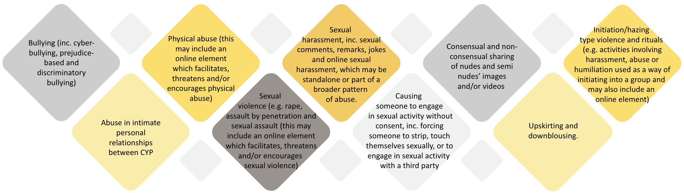
If staff have any concerns about Child-on-Child abuse, they will do the following: | - Record the allegation and tell the DSL, but do not investigate it.  - Pupils must be supported, and assurance be given to them that they are believed and taken seriously.  - The DSL will contact the local authority children’s social care team and follow its advice, as well as the police if the allegation involves a potential criminal offence.  - The DSL will put a risk assessment and support plan into place for all children involved (including the victim(s), the child(ren) against whom the allegation has been made and any others affected) with a named person they can talk to if needed.  - The DSL will contact the children and adolescent mental health services (CAMHS), if appropriate.
Harmful Sexual Behaviour (HSB)
Similar to the above, the school recognises that HSB can occur between children of any age or gender and may take place individually or in groups, either online or face-to-face.
HSB exists on a continuum, ranging from inappropriate behaviour to sexual harassment and sexual violence, and is always treated as a safeguarding and child protection concern – for both the child displaying the behaviours and those affected by or targeted by them.
There are various tools to help assess HSB including the Brook Traffic Light Tool and Hackett’s Continuum of HSB. We recognise that in many ways, HSB is preventable and can often be linked to misogynistic beliefs, comments and behaviours. Therefore, our zero-tolerance approach to these behaviours mean staff are confident in challenging these. Staff also understand that misogyny is a safeguarding concern, and the child may require further support in order to avoid their behaviour escalating.
All HSB concerns will be assessed by considering the age, developmental stage, maturity, and any power imbalance between the children involved (e.g. differences in age, physical size, disability, or social status).

Serious Youth Violence
Serious youth violence (SYV) is defined as ‘any offence of most serious violence or weapon-enabled crime, where the victim is aged 1-19’. This might include murder, manslaughter, rape, wounding with intent and causing grievous bodily harm. While knife crime is most common, SYV may also include threats involving or actual attacks using acid and corrosive substances or other weapons.

SYV can take place in the context of peer conflict or bullying, and it can also be associated with criminal exploitation. The likelihood of involvement in SYV may be increased by factors such as being male, frequent absence or exclusion from school, having experienced abuse, neglect or exploitation and having been involved in offending. However, staff are aware that SYV can also affect girls and young women.

Schools play a key role in protecting children from violence, safeguarding victims, as well as those who may be at risk of, or are involved in committing violence (who may also be victims themselves).
Signs and Indicators include (but are not limited to): |  | - Increased absence from school or college,  - A change in friendships or relationships with older individuals or groups,  - Self-harm or a significant change in wellbeing,  - Unexplained injuries. |  |  |  |  |  |  |  |  | If a member of staff has a concern about a pupil being involved in, or at risk of, serious violence including the child carrying or using a weapon (or expressing intent to do so), they must report this to the DSL immediately.
Sharing of nudes and semi-nudes
We are aware that the sharing of nudes and semi-nudes is generally reported in the media as being a safeguarding issue amongst older young people rather than primary-age children. However, as a school we are aware that research by the NSPCC has shown that children as young as 9 years old have been involved in incidents of sharing nudes or semi-nude images. We therefore ensure all of our staff are trained thoroughly to respond to such incidents and to support the children involved.
Staff responsibilities: |  |  |  |  |  | You must not:
If you are made aware of an incident involving the consensual or non-consensual sharing of nude or semi-nude images/videos including pseudo-images such as those created using AI or deepfake technology, you must report it to the DSL immediately.  Explain to the child that you need to report the incident and reassure the pupil(s) that they will receive support and help from the DSL. |  |  |  |  |  | - View, copy, print, share, store or save the images/videos yourself, or ask a pupil to share or download it (if you have already viewed the images/videos by accident, you must report this to the DSL)  - Delete the images/videos or ask the pupil to delete it.  - Ask the pupil(s) who are involved in the incident to disclose information regarding the images/videos (this is the DSL’s responsibility)  - Share information about the incident with other members of staff, the pupil(s) it involves or their, or other, parents and/or carers.  - Say or do anything to blame or shame any young people involved; or minimise the concerns due to their creation using AI.
Initial review meeting
Following a report of an incident, the DSL will hold an initial review meeting with appropriate school staff – this may include the staff member who reported the incident and the safeguarding or leadership team that deals with safeguarding concerns.
This meeting will consider the initial evidence and aim to determine: |  | - Whether there is an immediate risk to pupil(s)  - If a referral needs to be made to the police and/or children’s social care  - If it is necessary to view the image(s) in order to safeguard the young person (in most cases, images or videos should not be viewed)  - What further information is required to decide on the best response  - Whether the image(s) has been shared widely and via what services and/or platforms (this may be unknown) |  |  |  |  |  |  |  | - Whether immediate action should be taken to delete or remove images or videos from devices or online services  - Any relevant facts about the pupils involved which would influence risk assessment.  - If there is a need to contact another school, school, college, setting or individual.  - Whether to contact parents or carers of the pupils involved (in most cases parents/carers should be involved)
The DSL will make an immediate referral to police and/or children’s social care if: |  | - The incident involves an adult  - There is reason to believe that a young person has been coerced, blackmailed or groomed or if there are concerns about their capacity to consent (for example owing to special educational needs)  - What the DSL knows about the images or videos suggests the content depicts sexual acts which are unusual for the young person’s developmental stage or are violent  - The images/videos involve sexual acts and any pupil in the images or videos is under 13 |  |  |  |  |  |  |  | - The DSL has reason to believe a pupil is at immediate risk of harm owing to the sharing of nudes and semi-nudes (for example the young person is presenting as suicidal or self-harming)  - The incident involves cyberflashing  - The incident involves threatening communications (for example of death or serious injury)  - The incident involves sharing or threatening to share nude or semi-nude images including deepfake images
If none of the above apply then the DSL, in consultation with the Headteacher and other members of staff as appropriate, may decide to respond to the incident without involving the police or children’s social care. The decision will be made and recorded in line with the procedures set out in this policy.

The DSL uses tools and research including the Brook Traffic Light Tool, the NSPCC’s Framework for Harmful Sexual Behaviour and Finkelhor and Wolak’s document entitled “Sexting: A Typology” to help make decisions around each case.
Informing parents/ carers | The DSL will inform parents/carers at an early stage and keep them involved in the process, unless there is a good reason to believe that involving them would put the pupil at risk of harm. |  |  |  |  |  |  | Referring to the police |  |  |  | If it is necessary to refer an incident to the police, this will be done through informing our Early Help officer, a police community support officer, local neighbourhood police or dialling 101.
Curriculum coverage |  |  |  | Teaching covers the following in relation to the sharing of nudes and semi-nudes:
Pupils are taught about the issues surrounding the sharing of nudes and semi-nudes as part of our Relationships education / relationships and sex education, PSHE and computing programmes. |  |  |  | - What it is and how it is most likely to be encountered  - The consequences of requesting, forwarding or providing such images, including when it is and is not abusive and when it may be deemed as online sexual harassment.  - Issues of legality  - The risk of damage to people’s feelings and reputation  - A summary of this policy so they are aware of the processes the school will follow in the event of an incident.  - Pupils also learn the strategies and skills needed to manage the receipt of such images and specific requests or pressure to provide (or forward) such images.
Financially motivated Sexual Extortion or ‘Sextortion’ |  | In some cases, incidents of sharing nudes may initially appear as child-on-child due to the offender posing as a child online. However, upon further investigation, it may come to light that the incident is, in reality, adult aggravated.  In all cases involving an adult perpetrator, the DSL would immediately contact the police and children’s social care. These cases may be sexually motivated or constitute a case of ‘Financially motivated Sexual Extortion’, known commonly as ‘Sextortion’.  In 2024 for the first time, the National Crime Agency issued an alert to all education settings warning them of the rise in cases of Sextortion of children and young people (particularly male victims aged 14-18)
Key facts: |  |  |  |  |  |  | Signs and Indicators include:
- Sextortion is when young people (and adults) are forced into paying money or meeting another financial demand (such as purchasing a pre-paid gift card) after an offender has threatened to release nude or semi-nude images of them.  - The sexual images do not even have to be real. They may be deep faked images…or even just the threat that the offender has some images – even if they never evidence this to the young person.​  - Some sextortion might include the threat of sharing intimate information (such as that the young person HAS sent some nudes at some point to someone, or that they are sexually active)​ |  |  |  |  |  |  | - Stealing (from home, school, even their teachers and friends)​  - Appearing to be in a rush to return home, or to retrieve their devices​  - Panic about communications with parents/carers​  - Secrecy about online activities (inc. hiding devices)​  - Significant changes in behaviour e.g., mood swings, increased anxiety or anger, especially after using electronic devices or being online​  - Excessive use of the internet inc. throughout the night or at set times of day​  - An unusual or sudden decline in academic performance, truanting, or loss of interest in school-related activities and even hobbies.  - Becoming increasingly withdrawn and appearing pre-occupied.
If the DSL believes a child is – or could be – a victim of Sextortion, they will move swiftly to safeguard the child. Depending on the facts of the case, they will: |  |  | - Tell the child not to delete any images or communications with the perpetrator/s  - Tell the child not to send money or to declare the amount of money they have sent over, and the method by which they did this.  ALL Sextortion is a crime, no matter the child’s age so the police should always be contacted. Children’s Social Care or Adult Social Care (for young people over the age of 18) would be contacted in the majority of cases. |  |  |  |  |  | - Support the child to use tools such as: ‘Report Remove’, (The Internet Watch Foundation and Childline) or “Take It Down” (National Centre for Missing and Exploited Children) to report images that have been shared or might be shared online. ​  - Report directly to the platform or app that the incident has occurred on.  Unless doing so would place the child at further risk of harm, the DSL would liaise with parents/carers to ensure the child can be monitored and kept safe online.
Sexual Violence and Harassment between children in education settings.
It is important that school, school and college staff are aware of sexual violence and the fact children can, and sometimes do, abuse other children and young people in this way.
When referring to sexual violence, we are referring to sexual offences under the Sexual Offences Act 2003:
Rape: A person (A) commits an offence of rape if: he intentionally penetrates the vagina, anus or mouth of another person (B) with his penis, B does not consent to the penetration, and A does not reasonably believe that B consents. |  |  |  |  | Assault by Penetration: A person (A) commits an offence if: s/he intentionally penetrates the vagina or anus of another person (B) a body part (other than a penis) or an object, the penetration is sexual, B does not consent to the penetration and A does not reasonably believe that B consents. |  |  |  |  | Sexual Assault: A person (A) commits an offence of sexual assault if: s/he intentionally touches another person (B), the touching is sexual, B does not consent to the touching, and A does not reasonably believe that B consents. (NOTE - Schools and colleges should be aware that sexual assault covers a very wide range of behaviour so a single act of kissing someone without consent or touching someone’s bottom/breasts/genitalia without consent, can still constitute sexual assault).
What is consent? |  |  |  |  |  |  | What should staff do?
- Consent is about having the freedom and capacity to choose.  - Consent to sexual activity may be given to one sort of sexual activity but not another, e.g. to vaginal but not anal sex or penetration with conditions, such as wearing a condom.  - Consent can be withdrawn at any time during sexual activity, and each time activity occurs.  - Someone consents to vaginal, anal or oral penetration only if s/he agrees by choice to that penetration and has the freedom and capacity to make that choice:  - A child under the age of 13 can never consent to any sexual activity,  - The age of consent is 16  - Sexual intercourse without consent is rape.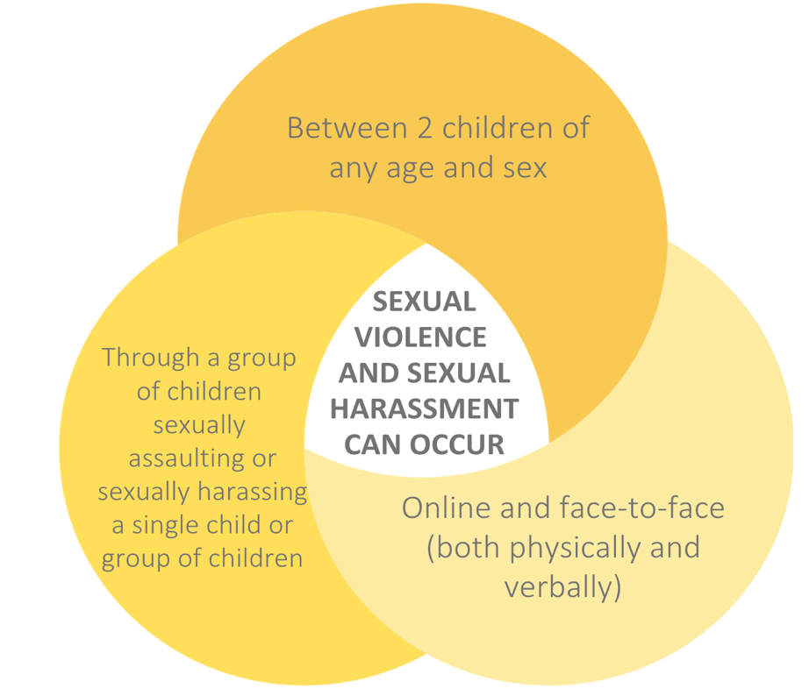 |  |  |  |  |  |  | Children who are victims of sexual violence and sexual harassment will likely find the experience stressful and distressing. This will, in all likelihood, adversely affect their educational attainment and will be exacerbated if the alleged perpetrator(s) attends the same school.  If a victim reports an incident, it is essential that staff make sure they are reassured that they are being taken seriously and that they will be supported and kept safe. Any concerns should be passed on to the DSL immediately.  A victim should never be given the impression that they are creating a problem by reporting sexual violence or sexual harassment. Nor should a victim ever be made to feel ashamed for making a report.  Some groups are potentially more at risk. Evidence shows that girls, children with SEN and/or disabilities, and lesbian, gay, bisexual and transgender (LGBTQ+) children are at greater risk.  - Further guidance can be found within Part 5 of KCSiE.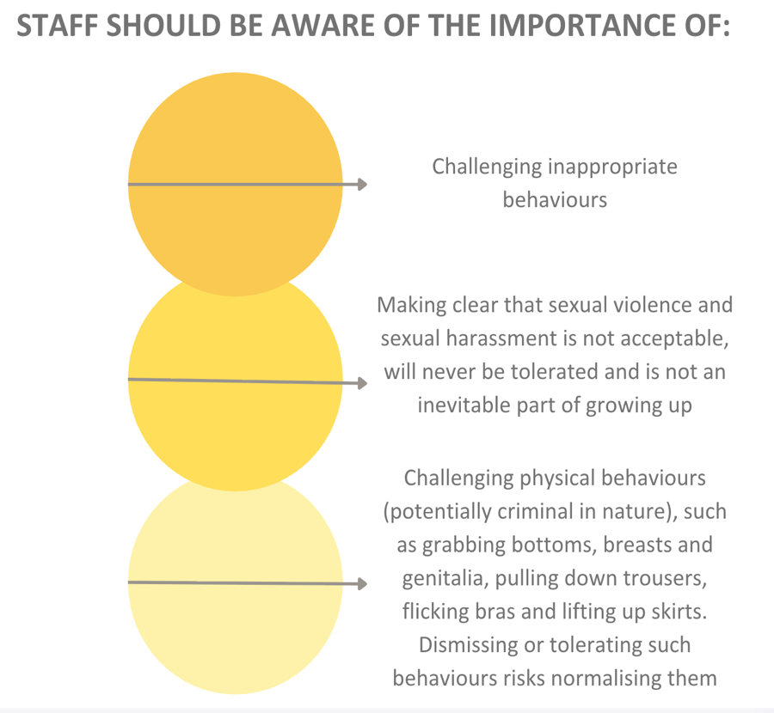

Upskirting and Downblousing
‘Upskirting’ typically involves taking a picture under a person’s clothing without them knowing, with the intention of viewing their genitals or buttocks to obtain sexual gratification, or cause the victim humiliation, distress or alarm. It is now a criminal offence. | ‘Downblousing’ refers to the using of a mobile camera or camera to take photos down one's blouse, shirt, or dress. This is usually done without the person’s knowledge or consent.
If a staff member becomes aware that a child has been subjected to upskirting or downblousing, this should be reported to the DSL.

How the DSL will handle cases of sexual violence
- Consideration will be given to whether the complaint raises a safeguarding concern and then report to the DSL.
- A factual record should be made but no attempt should be made to investigate at this stage,
- The DSL can discuss the case with advisory personnel such as the COG or the Education Safeguarding Officer to determine if a referral to MASH is required. If there is an indication that a criminal offence has been committed, then the police may become involved. The school may be advised to refer this case to the police or advise parents to do so.
- The DSL will speak to parents of the victim(s) and the alleged perpetrator to inform them of the referral as long as it does not put either party at risk of further harm.
- Records of action and advise will be kept on both children’s file.
- Consideration will be given to whether the alleged perpetrator should be excluded from the school according to the school’s Behaviour Policy
- If Children Services decide there will be no further action a thorough investigation will be carried out in the school using the school’s usual disciplinary procedure
- If the school consider a safeguarding risk is still present, then a full risk assessment will be carried out with a date set for follow up review.
Considering the perpetrator: | The alleged perpetrator is likely to have considerable unmet needs as well as posing a significant risk of harm to other children. Evidence suggests that such children may have suffered considerable disruption in their lives, may have witnessed or been subjected to physical or sexual abuse may have problems in their educational development and may have committed other offences. They may therefore be suffering, or at risk of suffering significant harm and in need of protection. Any long-term plan to reduce the risk posed by the alleged perpetrator must address their needs.
Risk assessing and taking action:
- When there has been a report of sexual violence, the DSL will make an immediate risk and needs assessment. Where there has been a report of sexual harassment, the need for a risk assessment will be considered on a case-by-case basis.

- Risk assessments will be recorded (paper or electronic) and will be kept under regular review. At all times, the school will be actively considering the risks posed to all their pupils and students and put adequate measures in place to protect them.

- The DSL will ensure they are engaging with local authority children’s social care and specialist services as required, working to local authority thresholds and involving them at the earliest possible opportunity (in regard to sexual violence).

- Where there has been a report of sexual violence, it is likely that professional risk assessments by social workers and or sexual violence specialists will be required. The school risk assessment mentioned above is not intended to replace the detailed assessments of expert professionals. Any such professional assessments would therefore be used to inform the school approach to supporting and protecting our pupils and students and updating our own risk assessment.

Please note: It is not the role of the school to provide legal advice or support to victims, alleged perpetrators or parents in respect of a criminal justice process. Rather, we take our own position and responsibilities seriously and act accordingly.
The risk and needs assessment for a report of sexual violence will consider: | - the victim, especially their protection and support  - whether there may have been other victims  - the alleged perpetrator(s) intra familial harms and any necessary support for siblings (both of victim/s and alleged perpetrator/s) following incidents  - all the other children, (and, if appropriate, adult students and staff) at the school or college, especially any actions that are appropriate to protect them from the alleged perpetrator(s), or from future harms, and  - The time and location of the incident, and any action required to make the location safer.
Confidentiality and Anonymity | In regard to reports of any form of abuse, neglect or exploitation, staff are trained to never promise confidentiality as it is very likely that it will be in the best interest of the victim to seek advice and guidance from others in order to provide support and engage appropriate agencies.  In regard to within the school, staff are trained to understand that maintaining the anonymity of the children involved is paramount. This is due to the high risk of the case being discussed on social media and/or this leading to bullying and further harassment.  For more information on how to deal with these cases, please consult KCSiE 2026

Appendix G: Safeguarding measures within EYFS

In line with the statutory requirements of the Early Years Foundation Stage (EYFS) framework, Harvills Hawthorn Primary School implements specific safeguarding measures to ensure the safety, dignity and wellbeing of our youngest children. These measures are embedded in our daily practice and reviewed regularly to maintain the highest standards of care.

We ensure safer eating practices by having a trained paediatric first aider present at all times when children are eating. This includes mealtimes, snack times and any cooking or tasting activities. The trained paediatric first aider is responsible for monitoring children closely, responding immediately to incidents such as choking or allergic reactions and ensuring that food provided meets any identified dietary or allergy needs. All EYFS children are always within sight and hearing of an adult during eating to promote safe supervision and timely intervention if required.

We ensure privacy during nappy changing, toileting and intimate care by carrying out these tasks in a designated, clean and safe area that allows the child’s dignity to be maintained while also meeting safeguarding requirements. Where possible, nappy changes and toileting support are carried out by familiar members of staff who know the child well. The layout of the changing and toileting area allows for visual or physical proximity to other staff members to provide safeguarding oversight without compromising the child’s privacy. All staff involved in intimate care follow our agreed procedures, which include wearing appropriate protective equipment, maintaining records of care provided and communicating with parents or carers where needed.

Appendix H: Allegations and Low-level (staff) concerns

When a safeguarding concern or allegation is made about a member of staff, (including supply staff, contractors or volunteers), or relates to an incident that happened when an individual or organisation was using our premises for the purposes of running activities for children, our set procedures must be followed.
The full procedures for dealing with allegations against staff and managing low level concerns raised about staff can be found in Part 4 of KCSiE 2026 and in the school’s safeguarding concerns and allegations made about staff, supply staff, contractors and volunteers’ policy and procedures.
Safeguarding concerns or allegations made about staff who no longer work at the school, or historical allegations will be reported to the police.
This section applies to cases in which it is alleged that a current member of staff (inc. a supply teacher, volunteer or contractor) has: | - Behaved in a way that has harmed a child, or may have harmed a child, and/or  - Possibly committed a criminal offence against or related to a child, and/or  - Behaved towards a child or children in a way that indicates he or she may pose a risk of harm to children, and/or  - Behaved or may have behaved in a way that indicates they may not be suitable to work with children – this includes behaviour taking place both inside and outside of the school  - In some circumstances, we may have to consider an allegation against an individual not directly employed by us (e.g., supply teachers, trainee teachers or contracted staff provided by an employment agency or business). In these circumstances, we share safeguarding responsibilities with the employment agency or business. We remain responsible for gathering the facts and managing the safeguarding process (including referring to and liaising with the LADO where relevant) while working closely with the employment agency or business, which would usually lead on any disciplinary action
We will deal with any allegation of abuse quickly, in a fair and consistent way that provides effective child protection while also supporting the individual who is the subject of the allegation.
A ‘case manager’ will lead any investigation. This will be the Headteacher, or the chair of governors where the Headteacher is the subject of the allegation. The case manager will be identified at the earliest opportunity.
Our procedures for dealing with allegations will be applied with common sense and judgement, using KCSiE 2026 to inform our decisions, and our local guidelines around referrals to the Local Authority Designated Officer (LADO).
Low-Level Concerns |  | We recognise the importance of responding to and dealing with any concerns in a timely manner to safeguard the welfare of children. Our policy regarding low-level concerns is based on KCSiE 2026.
The term ‘low-level’ concern does not mean that it is insignificant. A low-level concern is any concern – no matter how small, and even if no more than causing a sense of unease or a ‘nagging doubt’ - that an adult working in or on behalf of the school or college may have acted in a way that: |  |  |  |  | • is inconsistent with the staff code of conduct, including inappropriate conduct outside of work and  • does not meet the harm threshold or is otherwise not serious enough to consider a referral to the LADO
Examples include (but are not limited to): |  |  |  |  | Concerns may arise through:
- being over friendly with children  - having favourites  - taking photographs of children on their mobile phone, contrary to school policy |  |  |  |  | - Suspicion  - Complaint  - Disclosure made by a child, parent or other adult within or outside the school.  - Pre-employment vetting checks
It is vital to create a culture of openness, trust and transparency to encourage all staff to share low-level concerns. They can then be addressed appropriately. We achieve this by: |  |  | - Ensuring staff are clear about what appropriate behaviour is and are confident in distinguishing expected and appropriate behaviour from concerning, problematic or inappropriate behaviour, in themselves and others.  - Empowering staff to share any low-level concerns as per section 7.7 of this policy.  - Empowering staff to self-refer.  - Addressing unprofessional behaviour and supporting the individual to correct it at an early stage.  - Providing a responsive, sensitive and proportionate handling of such concerns when they are raised.  - Helping to identify any weakness in the school’s safeguarding system
Reporting a low-level concern |  |  |  | Responding to low-level concerns
- Concerns about a staff member (including volunteers, contractors etc) should be reported directly to the Headteacher.  - Concerns about the Headteacher or Headteacher should be reported to the Chair of Governors. |  |  |  | If the concern is raised via a third party, the Headteacher will collect evidence where necessary by speaking:  - Directly to the person who raised the concern, unless it has been raised anonymously.  - To the individual involved and any witnesses  The Headteacher will use the information collected to categorise the type of behaviour and determine any further action, in line with the school’s Staff Code of Conduct Policy.
Record keeping
All low-level concerns will be recorded in writing. In addition to details of the concern raised, records will include the context in which the concern arose, any action taken and the rationale for decisions and action taken.
Records will be:
- Kept confidential, held securely and comply with the Data (Use and Access) Act 2025.
- Reviewed so that potential patterns of concerning, problematic or inappropriate behaviour can be identified. Where a pattern of such behaviour is identified, we will decide on a course of action, either through our disciplinary procedures or, where a pattern of behaviour moves from a concern to meeting the harms threshold, we will refer it to the designated officer at the local authority.
- Retained at least until the individual leaves employment at the school.
Where a low-level concern relates to a supply teacher or contractor, we will notify the individual’s employer, so any potential patterns of inappropriate behaviour can be identified.
We will not include low-level concerns in references unless:
- The concern (or group of concerns) has met the threshold for referral to the designated officer at the local authority and is found to be substantiated; and/or
- The concern (or group of concerns) relates to issues which would ordinarily be included in a reference, such as misconduct or poor performance.

Appendix I: Alternative Provision (AP) and Managed Moves and Transfers (MM)

For a wide range of reasons including SEND or health needs, it may be in a student’s best interests to be educated either full or part time within an alternative provision placement. Some students may also benefit from a managed move or transfer to another school.

It is vital that all staff understand that students who are being educated within AP or who are on a managed move or transfer to another education setting remain on the school’s roll and remain the responsibility of the school.

A child or young person must never be considered ‘out of sight, out of mind’ and the school therefore puts in place stringent measures to ensure the safety and wellbeing of all students.
Measures to prioritise (AP and MM) student safety and wellbeing include: | - A Service Level Agreement with AP providers and partner schools that prioritises safeguarding and ensures swift communication if any concerns arise  - Only working with AP providers, we are satisfied can fully meet the student’s needs, including being provided with confirmation that all AP staff have had safeguarding training and are able to identify signs and indicators of abuse, neglect or exploitation  - Additional support for students with SEND or other needs to give them the best chance of success  - The DSL at the AP or managed move liaising immediately with the school’s DSL regarding any behaviour or safeguarding concerns, including attendance issues or changes  - Relevant historic safeguarding information and context being shared on a ‘need to know’ basis with the DSL at the AP or partner school to ensure the child’s needs are met  - AP providers acting without delay if there is a safeguarding concern, including contacting the police and/or children’s social care in emergencies and liaising with our school DSL in non-emergency situations
In addition, we will: | - Obtain written confirmation that appropriate safeguarding checks have been carried out on individuals working within the AP  - Be notified of any arrangements that may put the pupil at risk  - Remain fully aware of where a pupil is based during school or college hours (for example, if the AP is using a satellite site or going on an educational trip)  - Review AP placements at least half termly and if necessary, terminate any placements where safeguarding concerns arise
The cohort of pupils in Alternative Provision often have complex needs and can therefore be more vulnerable to certain forms of abuse, neglect and exploitation, including: |  | - Contextual safeguarding risks including CSE and CCE  - Sexual abuse and harassment  - Serious youth violence  - Mental health difficulties
It is our policy that children who are entering AP or being offered an MM will always be offered extensive school or community based early intervention measures in order to meet their needs, as well as the offer of a referral to statutory Early Help services.

Appendix J: Supporting Gender-Questioning Children

In recent years, there has been a significant increase in the number of children who are openly questioning the way they feel about being a boy or a girl, including the physical attributes of their sex and the related ways in which they fit into society. In response, successive governments have explored how to support schools to meet the needs of those children. We therefore work to the guidance outlined in KCSiE 2026.
When we refer to “social transition”, we refer to any changes or support put in place to facilitate the child presenting as the opposite biological sex. For example: | - A child using different pronouns to refer to themselves  - A child referring to themselves by a different name that is generally associated with the opposite sex or more “gender-neutral”.  - A child beginning to wear clothing (including school uniform) that is more generally associated with the opposite sex  - A child wishing to use changing rooms or toilets that are designated for members of the opposite sex (please see below for clarity in this area).
As a school, we will:
- Train staff to understand that every child is unique, and it is common and completely natural for children to engage in activities that are less typically associated with their sex.  - Never make assumptions that a child may be questioning their gender but rather will respond to any circumstances where a child or their parent has raised a request relating to social transition. When considering such a request, first consider and prioritise what is in the best interests of the child and other children.  - Not adopt any changes relating to social transition unless a decision has been made by a school or college alongside a child’s parents/carers taking into account all of the factors outlined below. Our decision-making process will be documented with records kept, and where necessary, reviewed.  - Comply with our obligations under safeguarding legislation and equality and human rights law, ensuring that any assessment of discrimination is informed by an evaluation of the welfare and best interests of the child - and other children.  - Prioritise working closely with parents or carers to determine what is in the best interests of the child as well as considering any clinical evidence or advice and seeking any additional non-clinical professional advice where relevant (for example from the SENCO and DSL) in order to take into account other factors such as wider health issues or neurodiversity. |  | - Not allow pupils into toilets, changing rooms, or boarding/residential accommodation (including on school residential trips) designated for the opposite sex, with no exceptions, in line with KCSiE. This will be the case whether other elements of social transition have been implemented. Similarly, where we have implemented single-sex sports as being necessary for safety reasons, pupils will not be allowed to participate in sports designated for the opposite sex.  - Appropriately sanction any cases of bullying or harassment in line with our behaviour policy, whilst also being conscious of the rights of pupils and staff in relation to their religion or belief.  - Ensure all relevant staff are aware of a child’s biological sex in all cases. We are legally required to record a child’s biological sex accurately wherever it is recorded.  Maintain flexibility and keep options open for children who have socially transitioned, working with parents/carers and relevant experts to support children who wish to fully or partially reverse a social transition request.
Should I always report to the DSL if a child tells me they are questioning their gender? | What might constitute a safeguarding risk?
No, not necessarily.  In cases where a child confides in a member of staff about their feelings/questions about their gender but does not ask the school to make changes to how they are treated, there is no reason to break any confidence unless there is a related safeguarding risk. | - If a child has made a request for support with social transition, it is important to involve the DSL. In the rare circumstances where involving parents/carers would constitute a greater risk to the child than not involving them, the DSL will need to determine what action is needed to safeguard the child, before the parents or carers are contacted or any decisions are taken.  - As the DSL is likely to be privy to more information about risks facing a child; it is important that nobody discusses the social transition request with parents/carers without first discussing with the DSL.  - Some children who socially transition before puberty will be “living in stealth” meaning other pupils and/or staff may be unaware of their biological sex. Staff should be particularly conscious of the vulnerabilities of such children. For example, they are likely to approach puberty in a fearful and anxious state and may require additional support.

Appendix K: Filtering and Monitoring

We take very seriously our responsibility to safeguard and promote the welfare of children and provide them with a safe environment in which to learn and implementing filtering and monitoring systems and processes is a key part of this. Filtering and Monitoring systems enable us to limit as much as possible, children’s exposure to the online risks from the school’s IT system.
We adhere to the government standards published in: Meeting digital and technology standards in schools and colleges - Filtering and monitoring standards for schools and colleges - Guidance - GOV.UK (www.gov.uk)
At this school, we use the following system/s: |  | Filtering: London Grid for Learning  Monitoring: Senso
- Online Safety and Filtering and Monitoring is the responsibility of the DSL. They are supported in this by the governing body and together, they review the effectiveness of the systems, at least on an annual basis. We use a range of tools to help us review, including the Prevent Duty risk assessment.
- It is vital that Filtering and Monitoring helps us to keep children safe but does not lead to ‘over blocking’ – creating unreasonable restrictions as to what children can be taught with regard to online teaching and safeguarding. Examples could be children being unable to access factual information relating to a project or being blocked from accessing helpful resources and websites to seek support.
Staff working with children are in key positions to spot any concerns and to escalate these to the DSL, recognising them as a potential safeguarding risk. Examples include: |  | - Spotting or overhearing that students have managed to override a system and access inappropriate content online.  - Spotting or overhearing students being able to use slang terms that are not recognised by the filtering and monitoring system and using these to search for and access inappropriate content.  - Spotting that inappropriate settings have been placed on video-sharing sites such as YouTube enabling for harmful or inappropriate videos to be accidentally shared with students.
Our filtering and monitoring system sends us daily alerts of when a child may have attempted to access harmful or inappropriate content. These are monitored and responded to on a daily basis by: Joanne Sheen, Maxine Soper, Ross Griffiths
Upon receiving an alert or notification, the DSL will consider whether there is any risk to the child. Action may be taken, including: | - Liaison with other professionals working with the child such as Police, Children’s Social Care, CAMHS/CYPMHS  - Liaison with parents/carers  - Actioning another member of staff such as a form tutor or mentor to speak further with the child and explore support options.  - Referrals

Appendix L: Benedict’s Law – Allergies and other medical conditions

As part of our safeguarding duties, we have a particular safeguarding responsibility for children with allergies and health conditions. Please see our policy on First Aid and Managing Medical Conditions which can be found on the staff drive.

The fact that there has been an incident relating to the management of a child or young person’s medical condition (including allergies) would not in and of itself warrant a referral to Children’s Social Services. Rather, a safeguarding referral would only be needed where an incident highlighted concern that the child or young person might be at an increased risk of being neglected, abused or exploited by persons inside or outside of their family unit because of their medical condition. This might occur where relevant information about a child or young person’s medical condition is not provided to a school, college or setting, or where they are repeatedly sent without essential medication, thereby putting the individual at risk.

The following is a summary of what we have in place to safeguard children with allergies (whether diagnosed or not):
- A large number of trained first aiders – all of whom are listed on posters around the school sites.  - All staff have regular training on allergies and anaphylaxis (including signs and indicators) and how to deal with emergency allergy situations.  - A member of staff who is a trained Paediatric First Aider will always be present when EYFS children are eating.  - We maintain an accurate register of pupils with diagnosed allergies. This is shared on a need-to-know basis with relevant staff. |  | - Families are regularly asked to update school about any potential allergies or intolerances. If the child does not already have one, an allegry management plan will be created alongside parents/carers as well as any medical professionals involved. If a child is at risk of severe allergic reaction, an Individual Healthcare Plan will be created. These will be reviewed annually or sooner, if needs change.  - A copy of these will be printed and laminated and kept in the school canteen. Canteen staff are expected to check this daily.  - All allergic reactions and near-misses are to be recorded and analysed by key staff in order to risk assess and ensure any plans are updated immediately.
The school has spare adrenaline auto-injectors (often referred to as “epipens”), salbutamol inhalers and of course, first aid kits that are regularly checked and replaced where necessary. |  | First aid kits are kept: | Spare inhalers and AAIs are kept:
 |  | Classrooms  Medical Room  On trained staff during lunchtime and during visits | AAIs – in school office in the medical cabinet  Inhalers – in Medical Room
Risk assessments will be regularly completed by catering staff (as well as school staff responsible for specific activities/trips) for: | - Classrooms (Including but not limited to, for food technology lessons)  - Dining areas,  - School trips and extracurricular activities where food may be prepared and/or consumed  - Breakfast and after-school clubs  - Celebrations and fundraising events where food may be prepared and/or consumed

